AWS DNS Services Project

Contents

Hosting a static website on Amazon S3 2

Project 1: Registering domain name on Route53 2

Hosted zones 2

Let’s get started with Registering domain name on Route53 3

Create 2 AWS Buckets. 8

Configure Root domain bucket for web hosting 11

Configure Sub domain bucket for web hosting 16

Enable logging 17

Upload files to the bucket 20

Edit S3 Block Public Access settings 20

Edit root domain bucket policy 21

Finally test if website is up 23

Add alias to domain and sub domain 24

Test the website 29

Learnings 29

# Hosting a static website on Amazon S3

## Project 1: Registering domain name on Route53

Route53 is a highly available and scalable DNS service offered by AWS. DNS is a service that maps human readable web addresses, for instance ‘Cloudbyms.click’ to a certain IP address (123.233.232.232) that points to a server. Route53 can be considered as a DNS hosted and managed by AWS. AWS incurs charges on different components and usage of this service. Apart from that requests up to a certain limit are exempted from charges if requests are made to certain AWS services. It is highly recommended that one checks [pricing model](https://aws.amazon.com/route53/pricing/).

It consists of what is known as ‘Hosted Zones’, which analogous to Zone File System in a traditional DNS system. Up to 10,000 records aren’t charged, anything beyond that is chargeable. Route53 is quite expensive to its competitors, however it allows DNS registration from 3rd party vendors outside AWS ecosystem. The information can be updated in Hosted Zones, and it will in return give you a list of DNS servers which one will update in 3rd party DNS providers portal. Route53 is responsible for routing traffic between AWS services and outside on the internet.

### Hosted zones

Specify how you want Route 53 to respond to DNS queries for a domain such as example.com.

### Let’s get started with Registering domain name on Route53

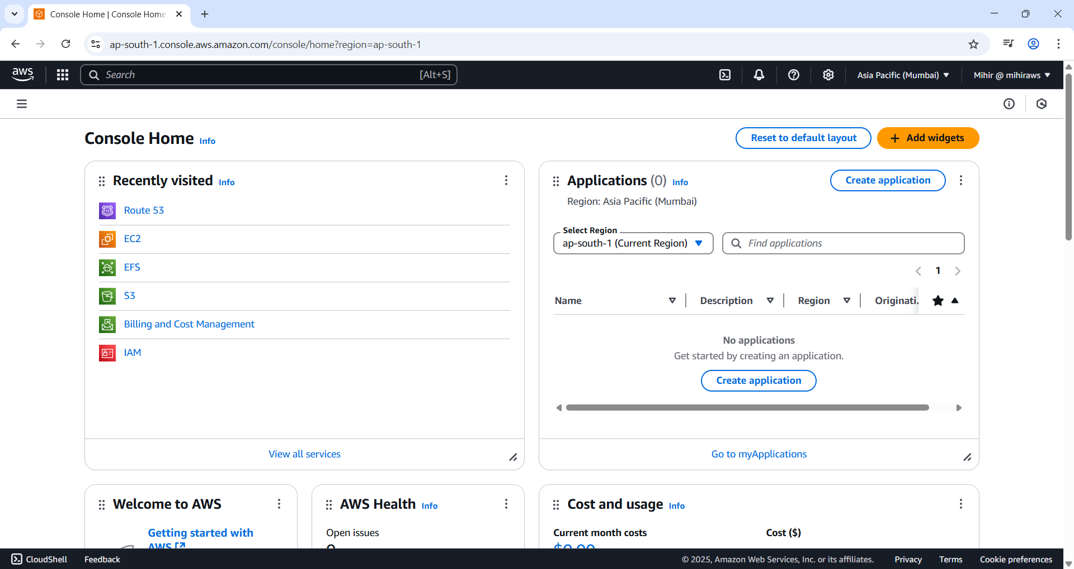

Figure 1 Search Route53 on Search bar.

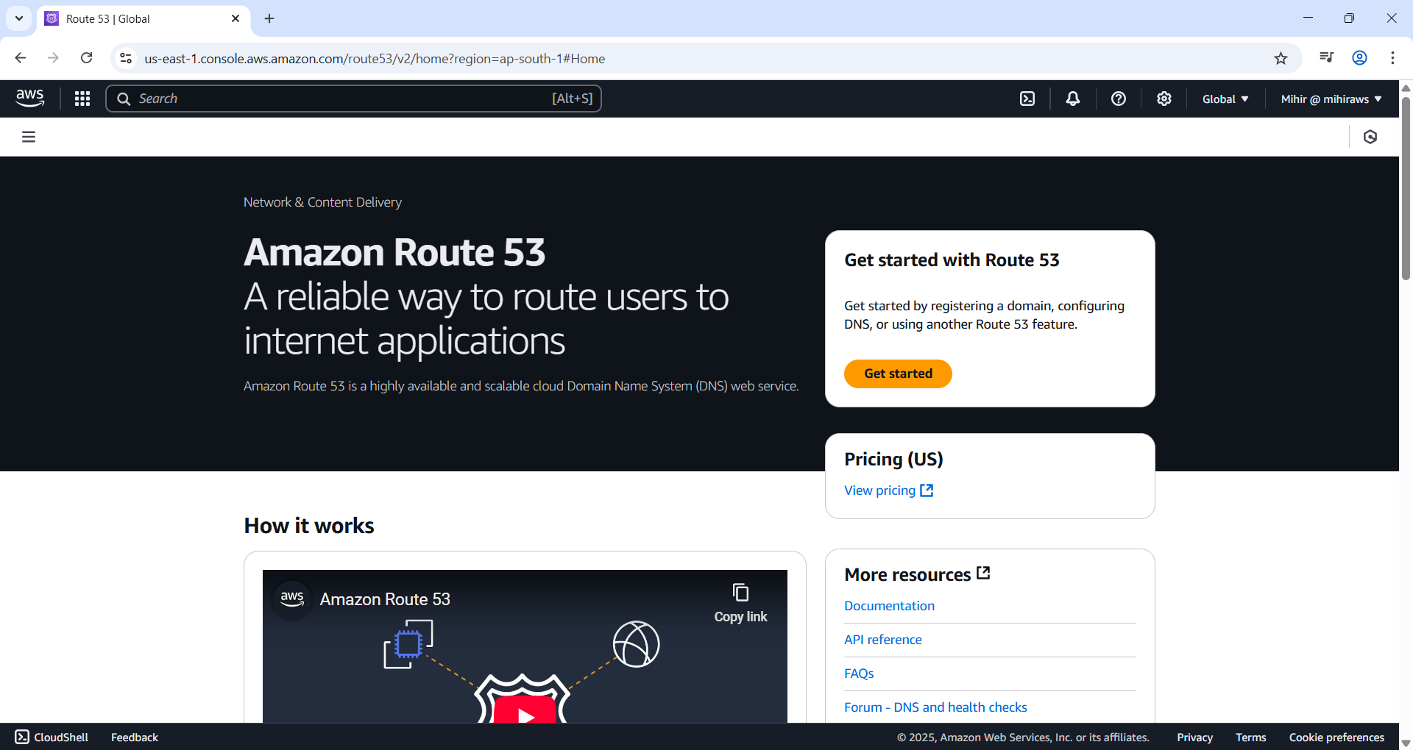

Figure 2 Route53 console and hit ‘Get Started’

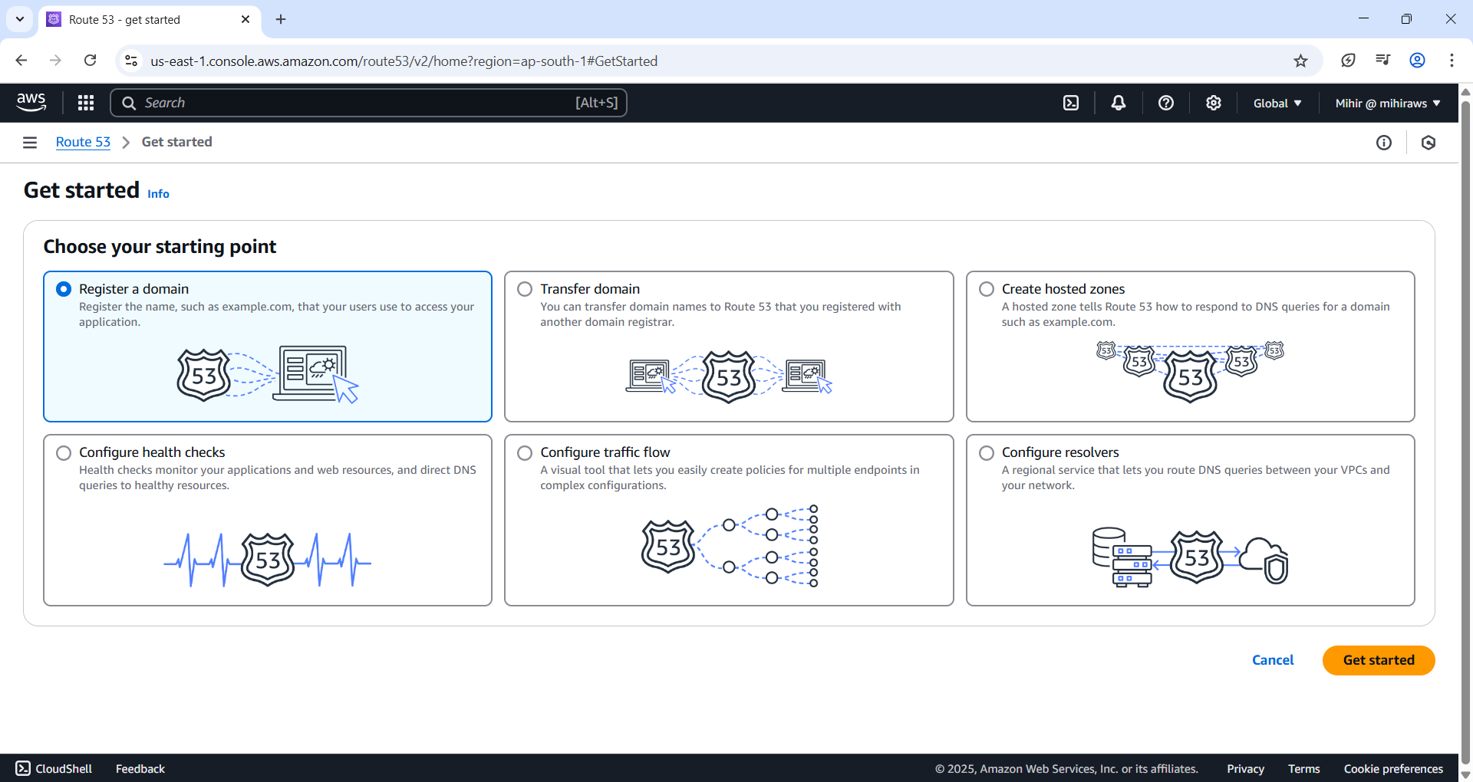

Figure 3 Select register a domain and hit ‘Get started’ button.

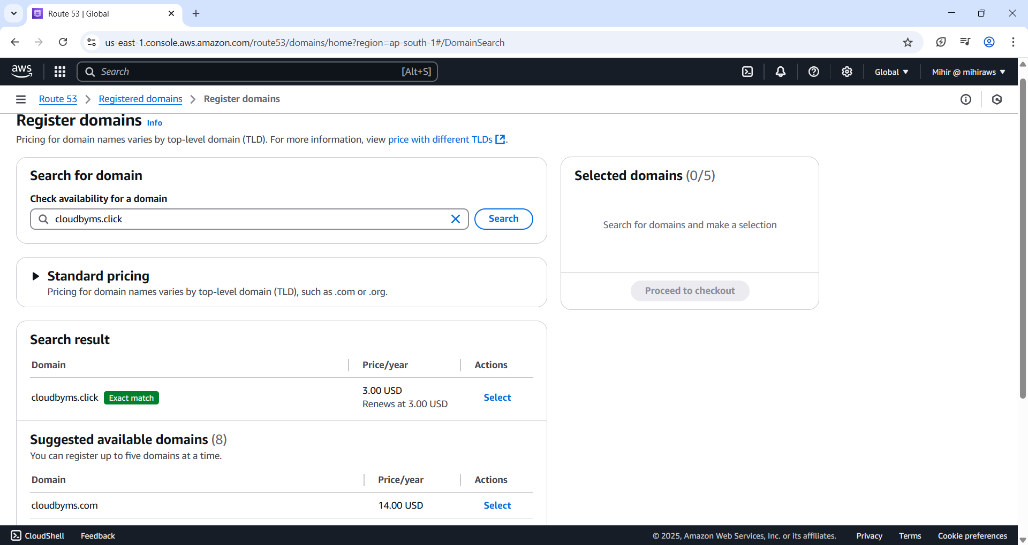

Figure 4 Search for available domain and select the pricing and TLD that's appropriate for you. I have selected the cheapest that cost me $3USD per year and set auto-renew to off. This is because I don’t intend to use beyond my AWS learning.

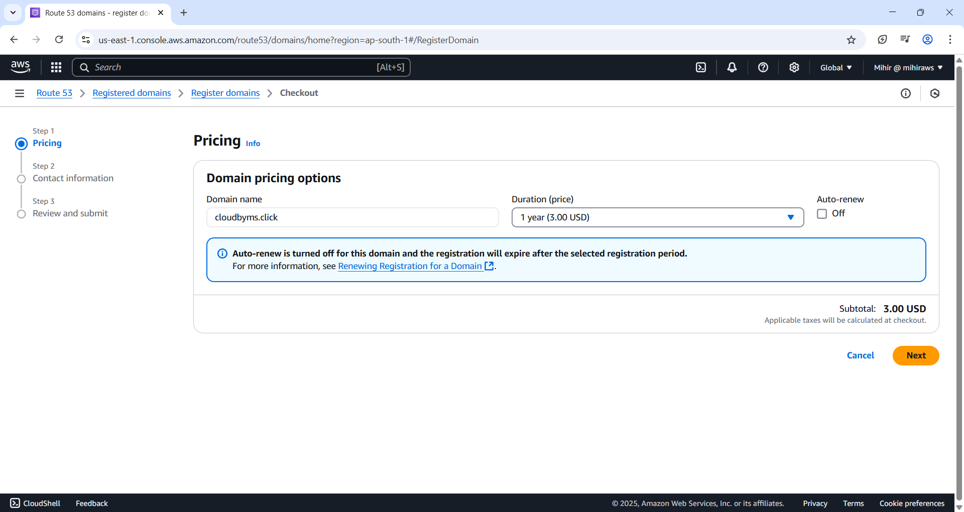

Figure 5 Uncheck ‘Auto renew’ to ‘Off’ unless you intend to use it longer.

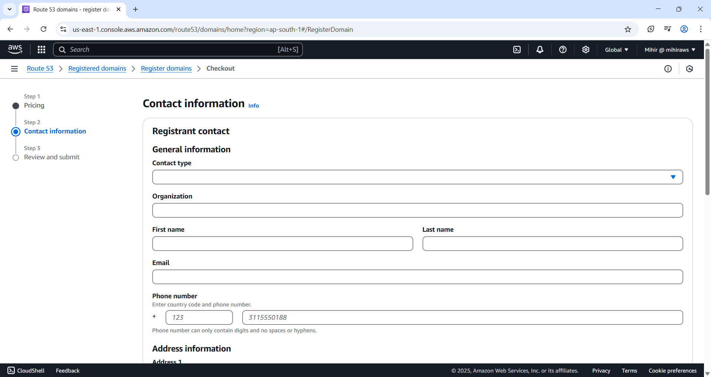

Figure 6 Fill in your personal info

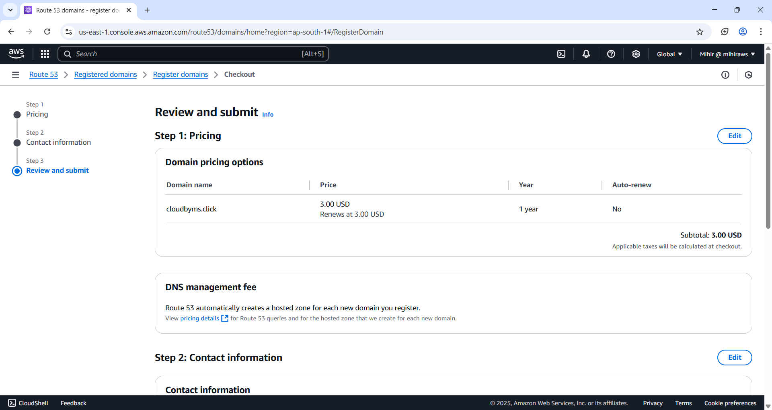

Figure 7 Review.

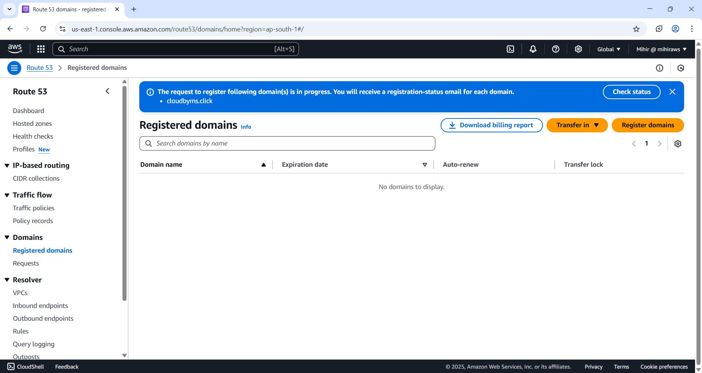

Figure 8 Domain Registration under process

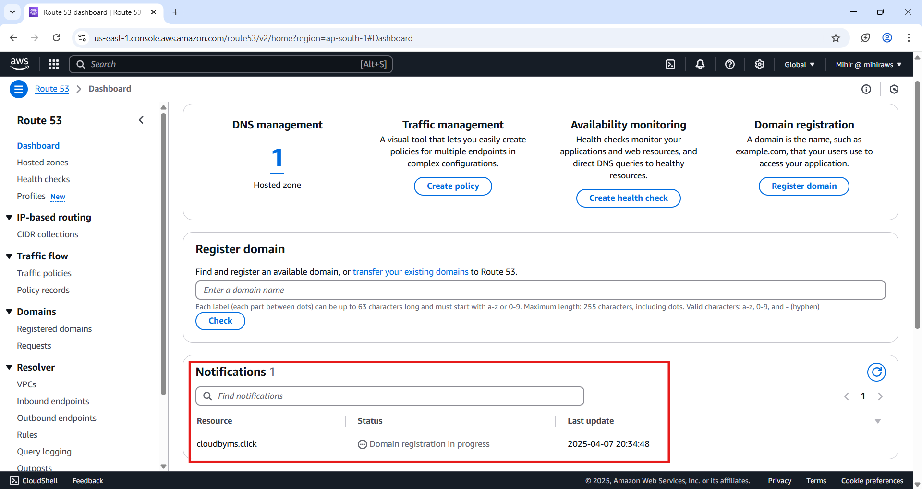

Figure 9 Click on 'Dashboard' on left pane and under 'Notifications' tab you should find your domain currently under progress.

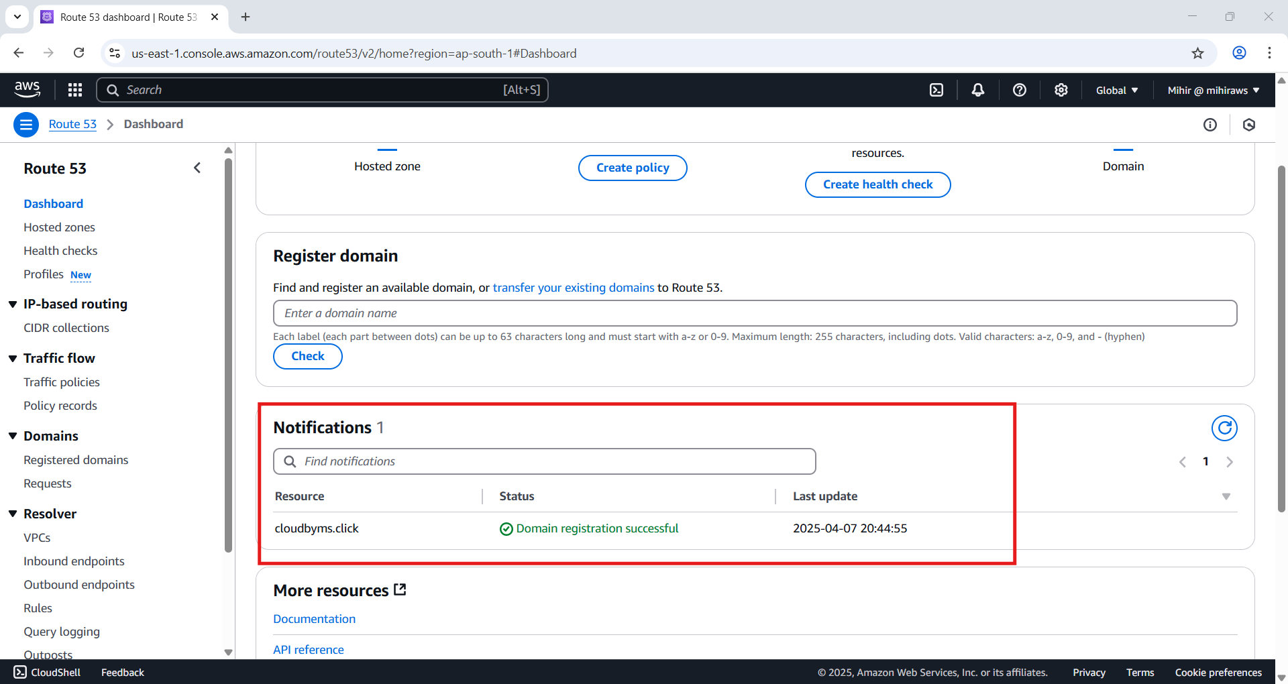

Figure 10 My domain is successfully registered

### Create 2 AWS Buckets.

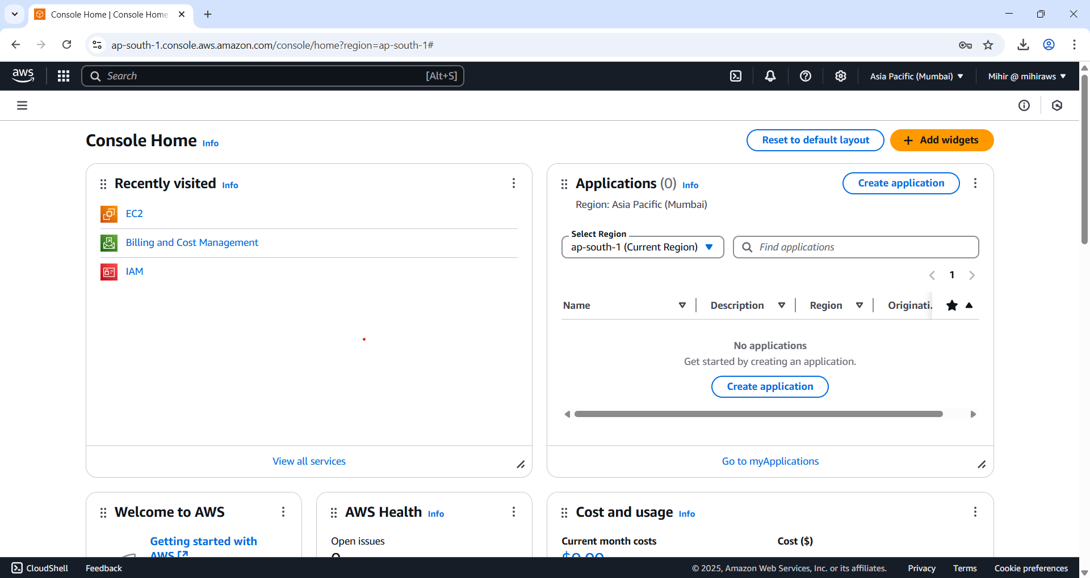

Figure 11 Go to AWS Console and search S3 in search bar.

We need to create 2 buckets namely cloudbyms.click and [www.cloudbyms.click](http://www.cloudbyms.click) since if someone types in www.cloudbyms.click it will be redirected to root cloudbyms.click domain. This is particularly necessary that the name of the bucket should be exactly same as registered domain name in this example for me I use ‘cloudbyms.click’.

These bucket names must match your domain name exactly. In this example, the domain name is example.com. You host your content out of the root domain bucket (example.com). You create a redirect request for the subdomain bucket (www.example.com). If someone enters www.example.com in their browser, they are redirected to example.com and see the content that is hosted in the Amazon S3 bucket with that name.

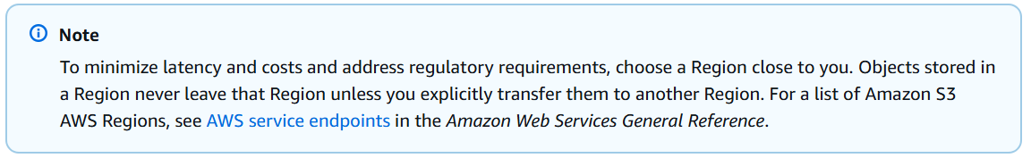

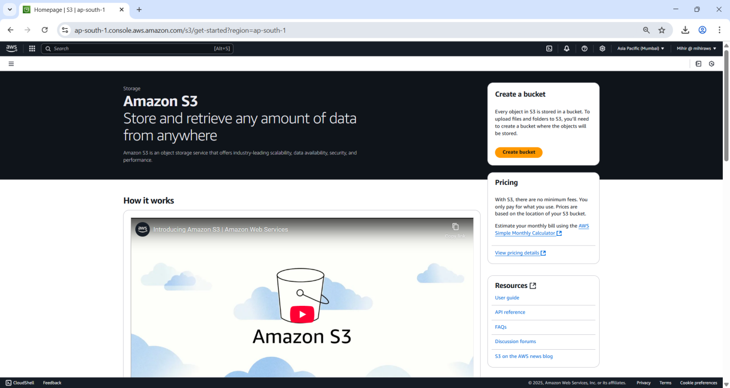

Figure 12 Hit Create Bucket

*Choose a Region that is geographically close to you to minimize latency and costs, or to address regulatory requirements. The Region that you choose determines your Amazon S3 website endpoint.*

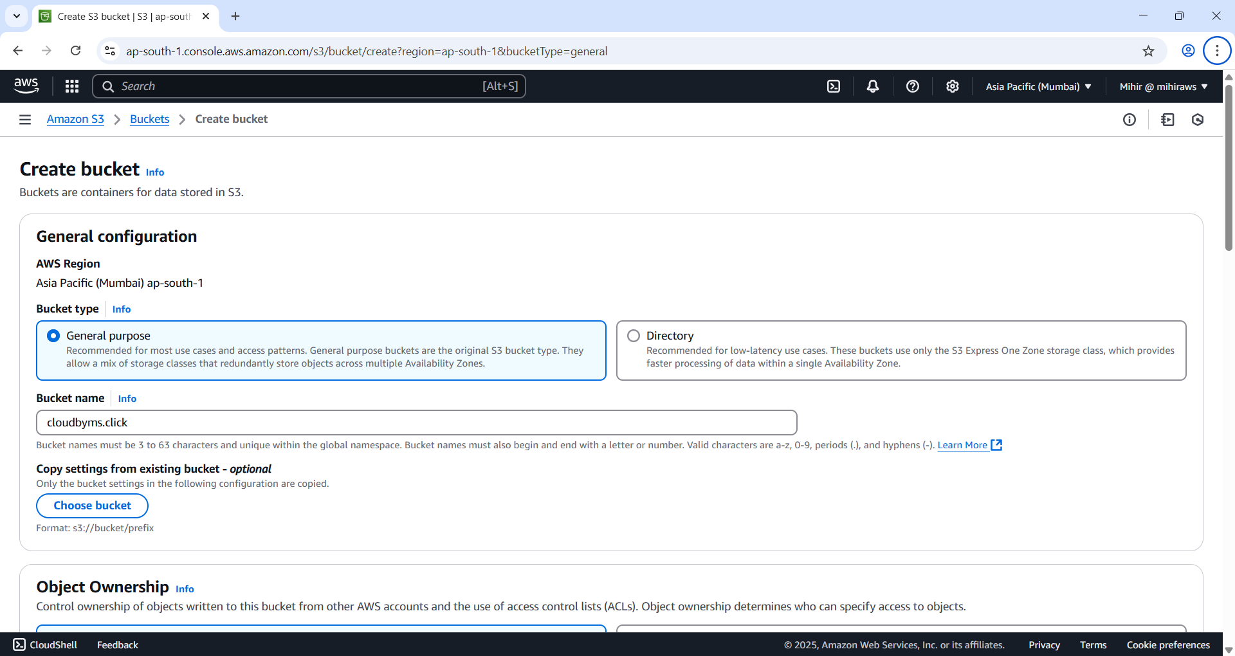

Figure 13 Name the root domain as your registered domain name and select bucket type as ‘General purpose’ bucket’. Leave rest of the settings to default.

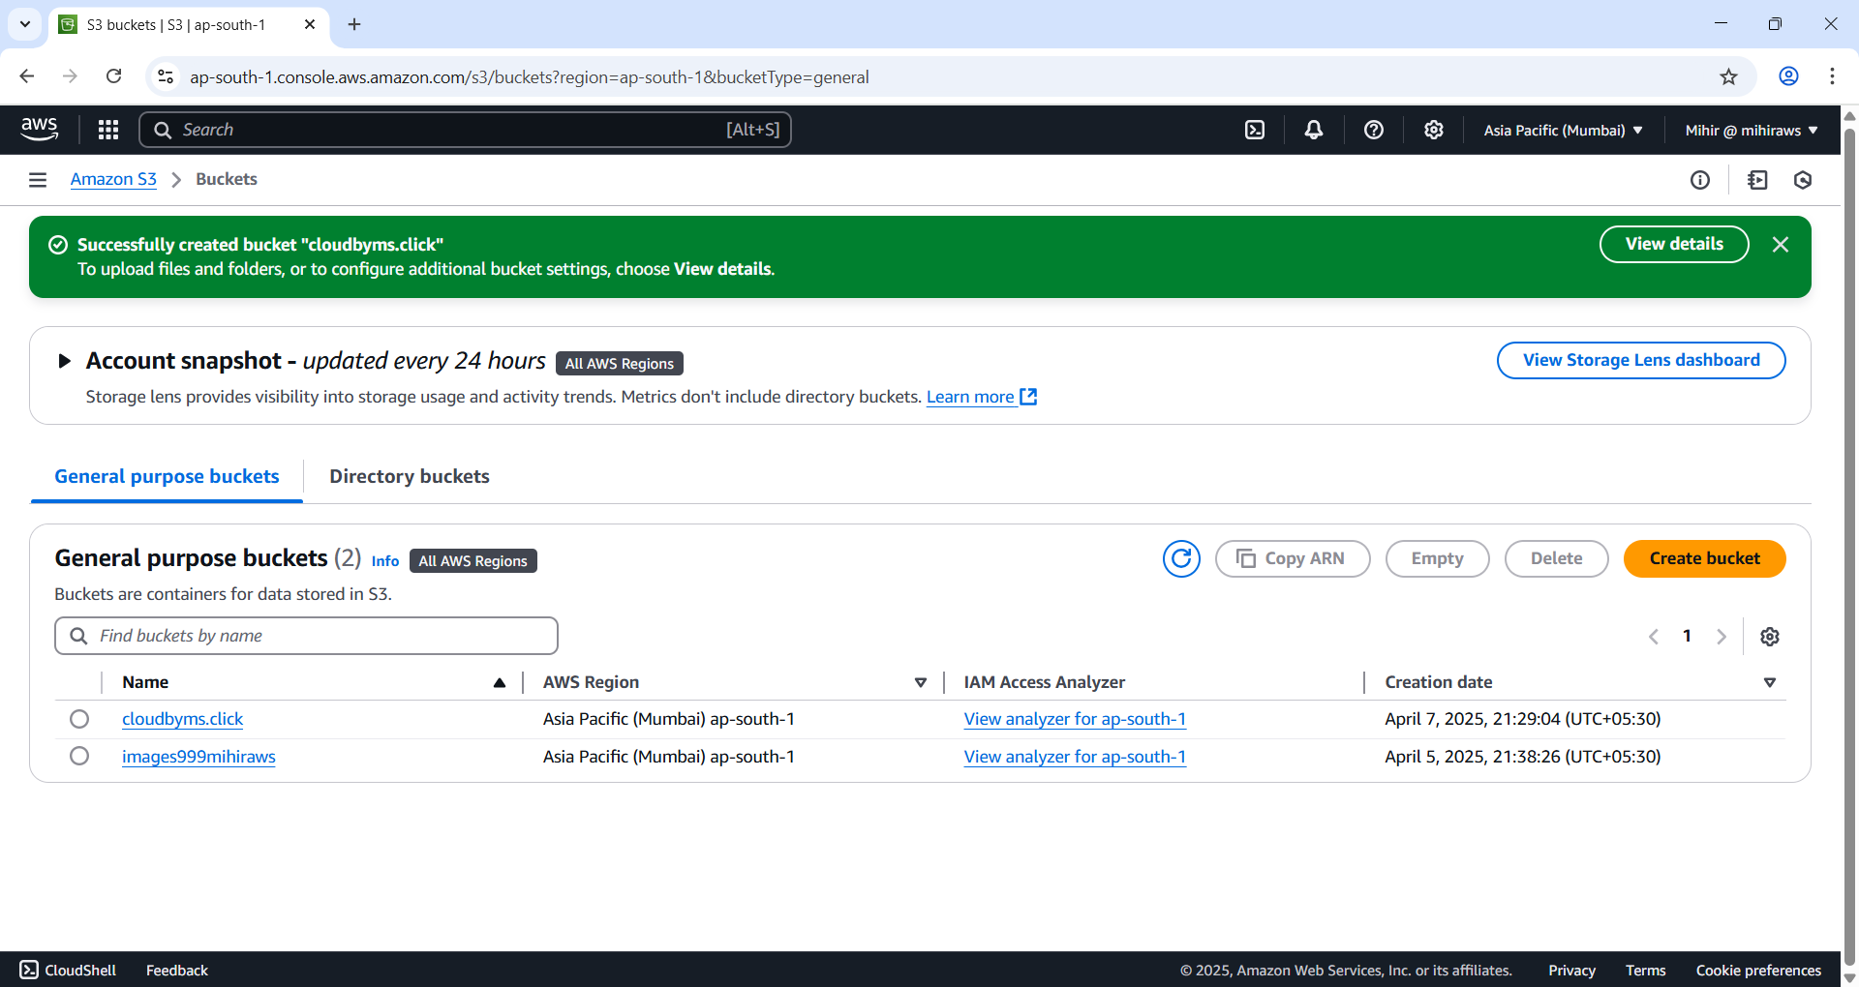

Figure 14 Root bucket created. Repeat the same procedure for sub-domain bucket by pre-fixing www. to the name of the bucket.

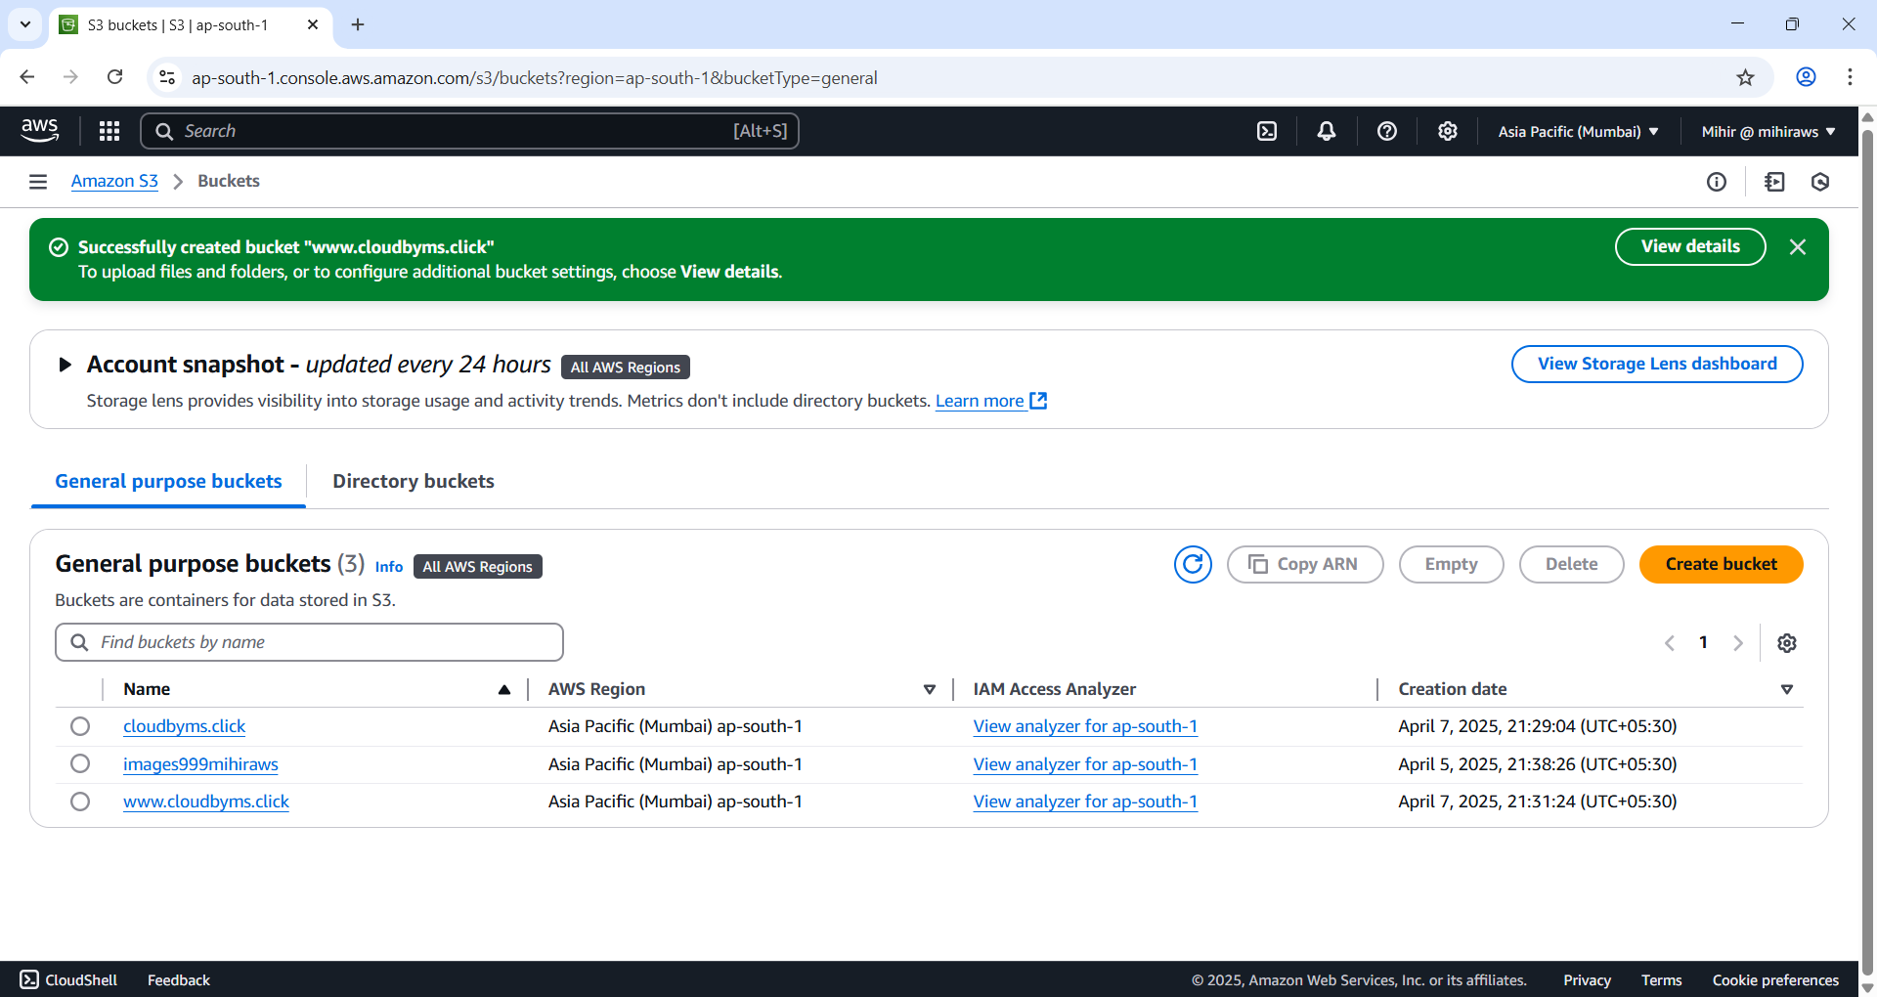

Figure 15 Successfully created subdomain bucket.

### Configure Root domain bucket for web hosting

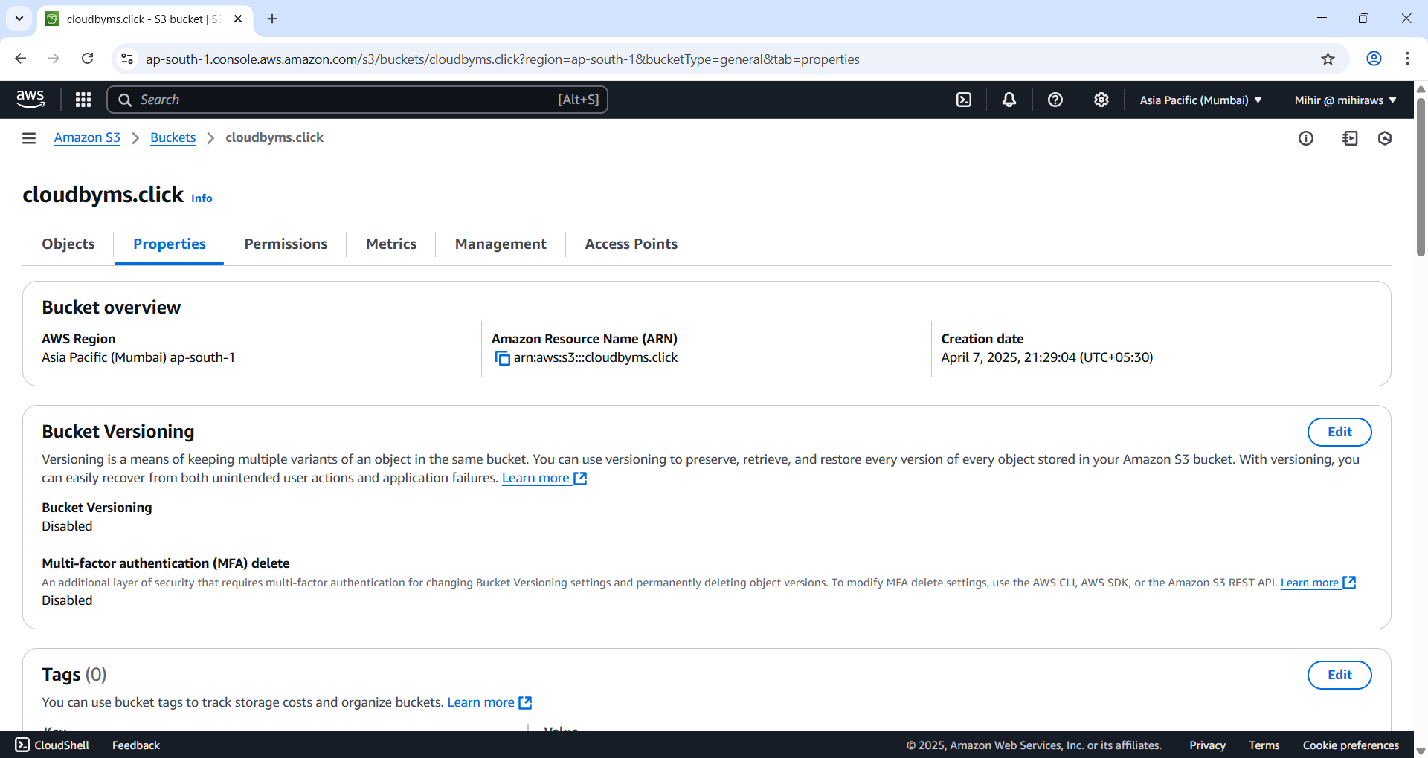

Figure 16 Go to 'Properties' tab under the root bucket you selected.

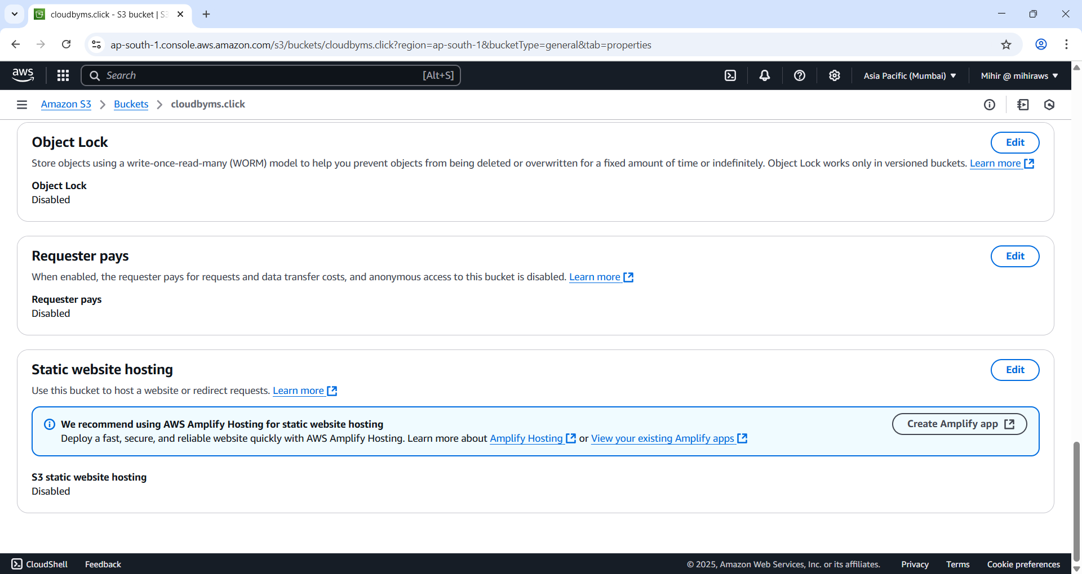

Figure 17 Under 'Static Website Hosting' select 'edit' button.

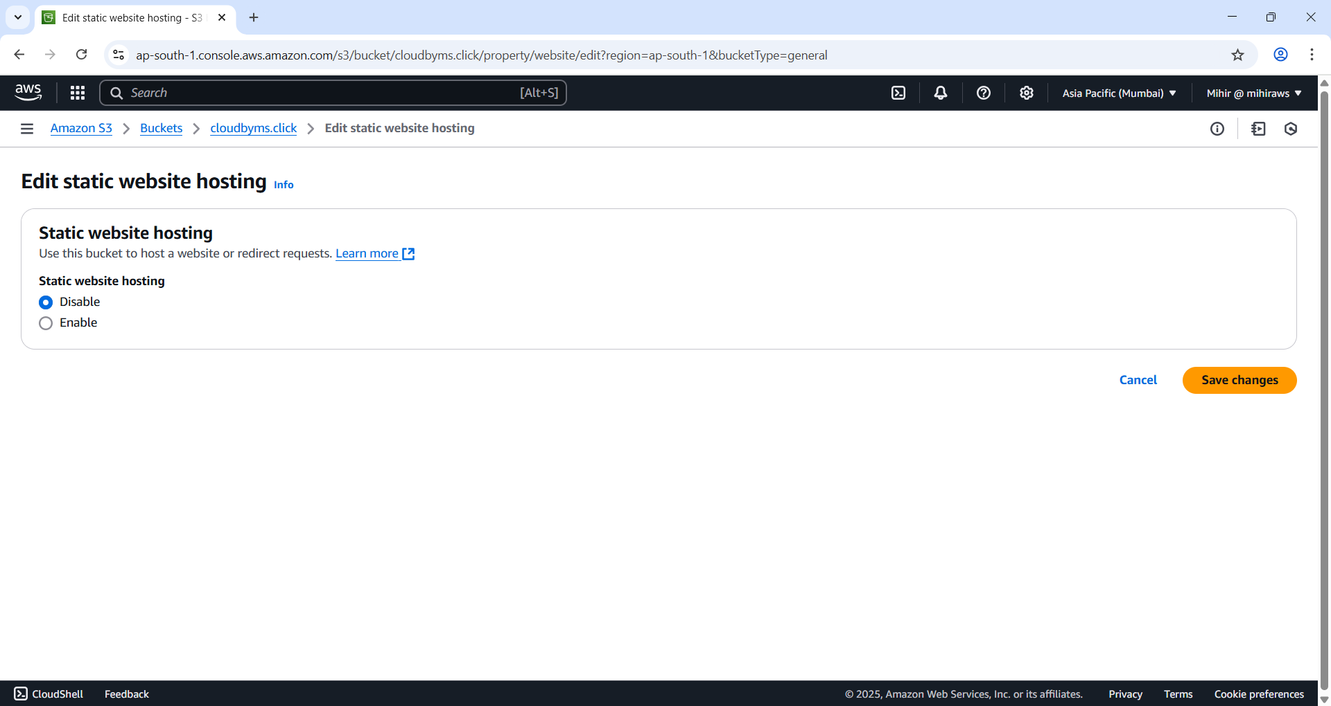

Figure 18 Select ‘Enable’.

Specify the exact, case-sensitive name of your index document (e.g., index.html). This file is required when enabling static website hosting on your S3 bucket. Amazon S3 serves this document by default when users visit the root domain or any subdirectory of your site.

To use a custom error page for 4XX errors, enter the exact, case-sensitive file name of your error document (e.g., error.html). This file must be uploaded to your S3 bucket. If not specified, Amazon S3 will display its default error page when an error occurs.

(Optional) To set up advanced redirection, enter JSON in the **Redirection rules** field. These rules let you conditionally redirect requests based on object key names or prefixes. For details, see *Configure redirection rules for advanced conditional redirects*.

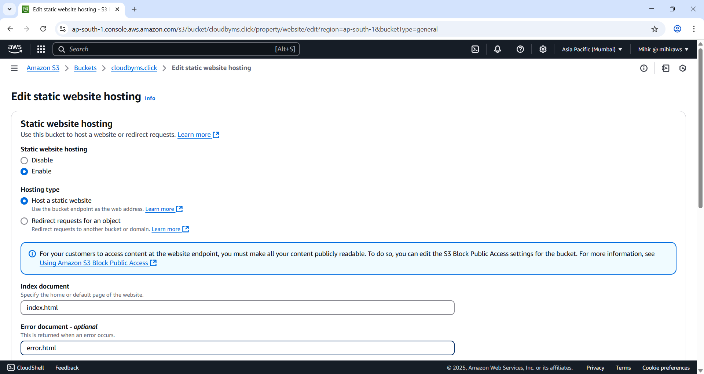

Figure 19 Enter exact file name you want to refer as index and error file name. If you don't specify error file Amazon will load a default error page. Also file names are case sensitive.

File names are case sensitive make sure you type in correctly.

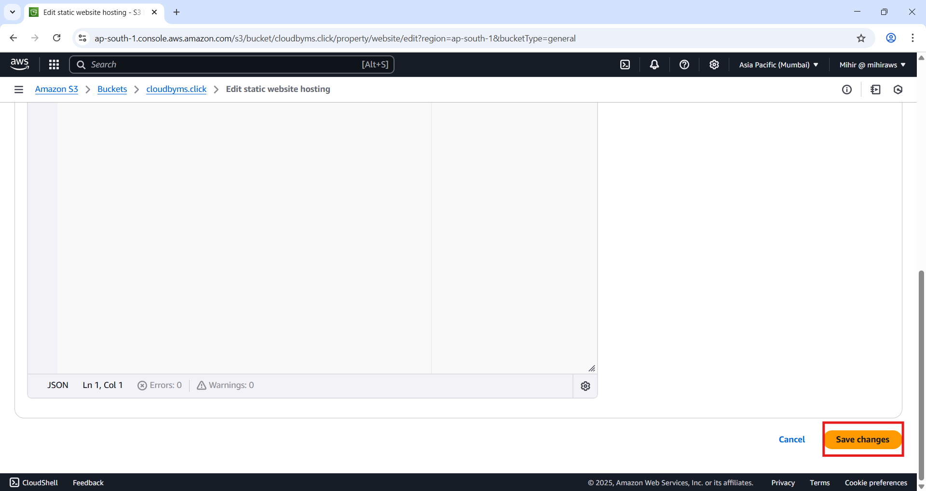

Figure 20 Save the changes.

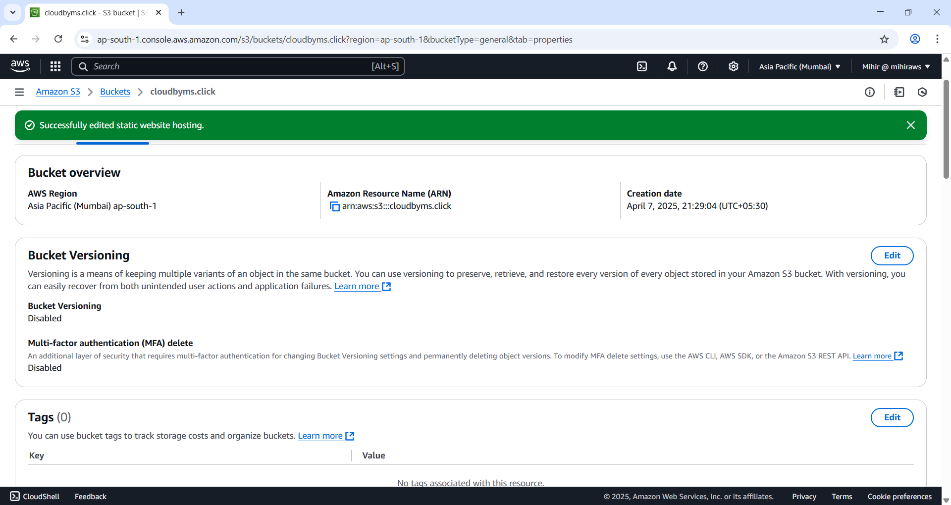

Figure 21 We successfully edited the bucket for hosting static website.

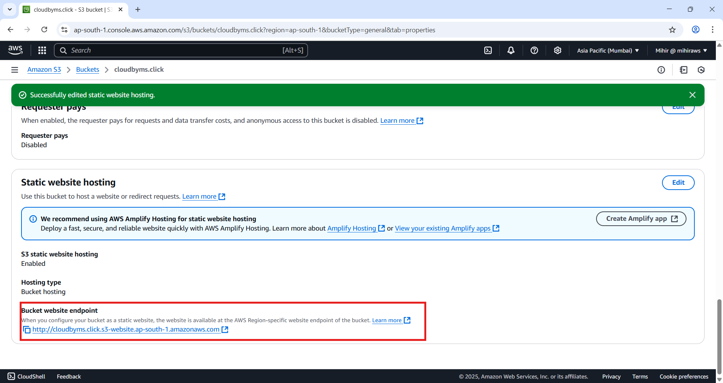

Figure 22 Static website endpoint created.

Under Static Website Hosting, take note of the **Endpoint**.

This is the Amazon S3 website URL for your bucket. Once you've completed the configuration to host your bucket as a static website, you can use this endpoint to access and test your site.

Once you've modified the block public access settings and added a bucket policy that grants public read access, you can use the website endpoint to view your website.

### Configure Sub domain bucket for web hosting

Repeat the initial steps for the subdomain bucket until you reach Static website hosting under properties tab of subdomain bucket.

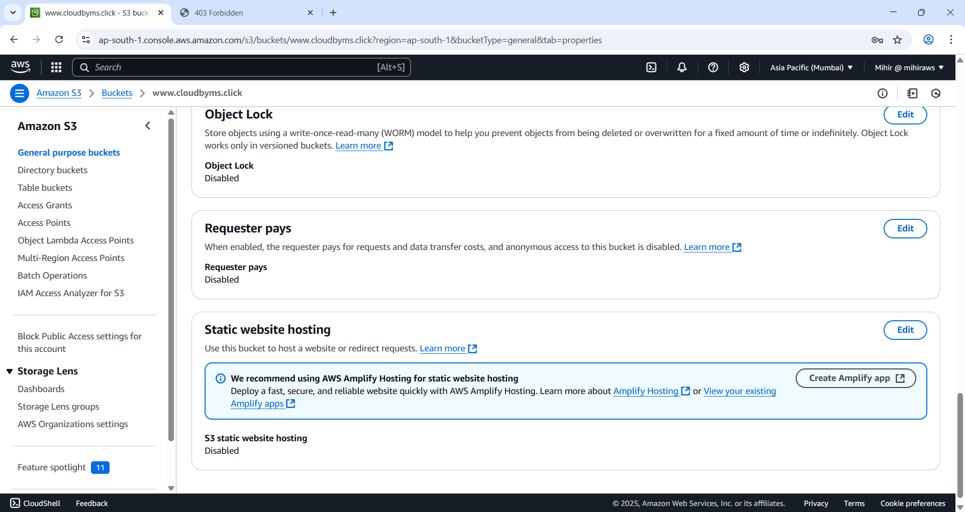

Figure 23 Just like previous steps go and edit the Static website hosting under subdomain bucket.

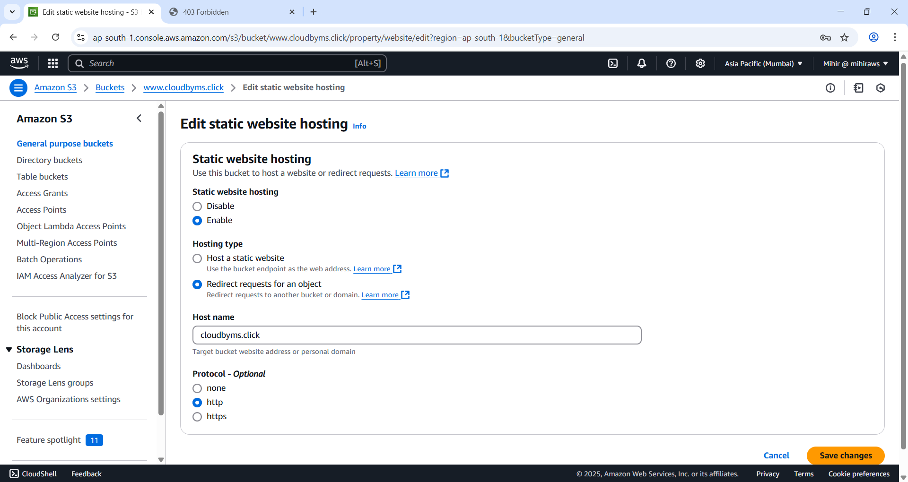

Figure 24 Enable and set Hosting Type as 'Redirect requests for an objects'. Under hostname specify root domain and protocol as http.

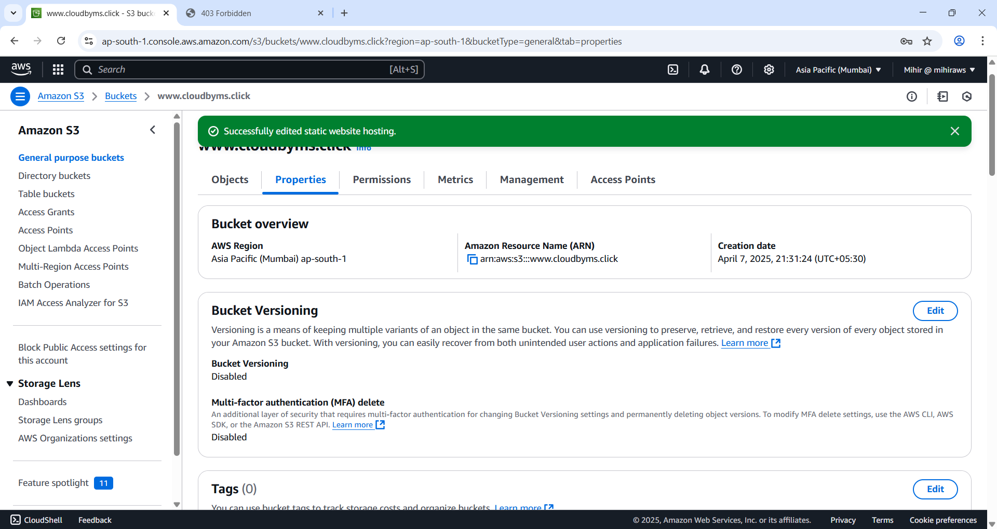

Figure 25 Successfully edited.

### Enable logging

Create new bucket name logs.yourdomain.tld

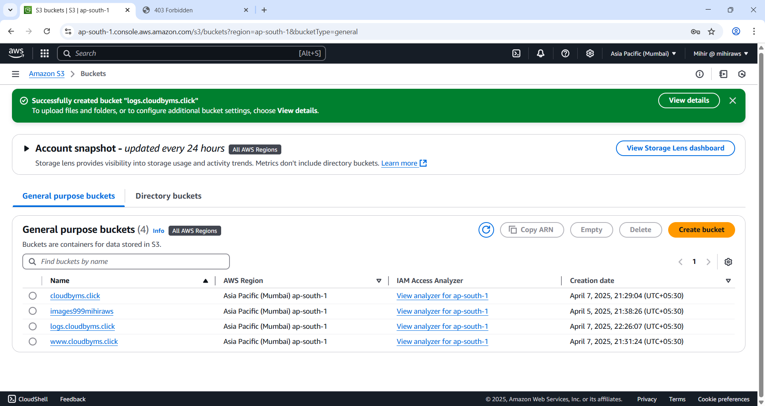

Figure 26 I created logs.cloudbyms.click

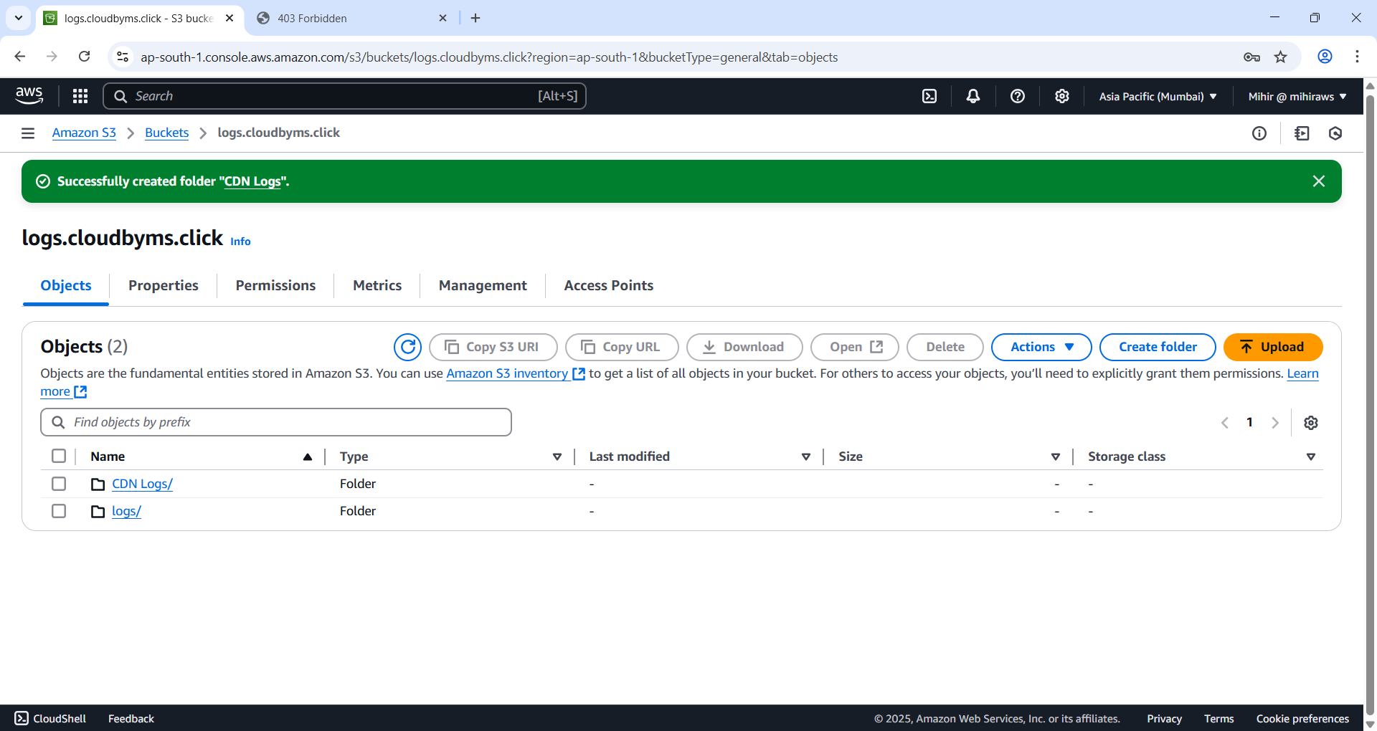

Figure 27 Create two folders under bucket.

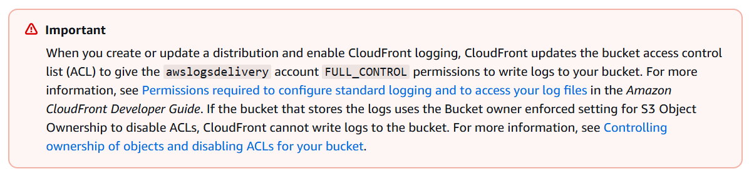

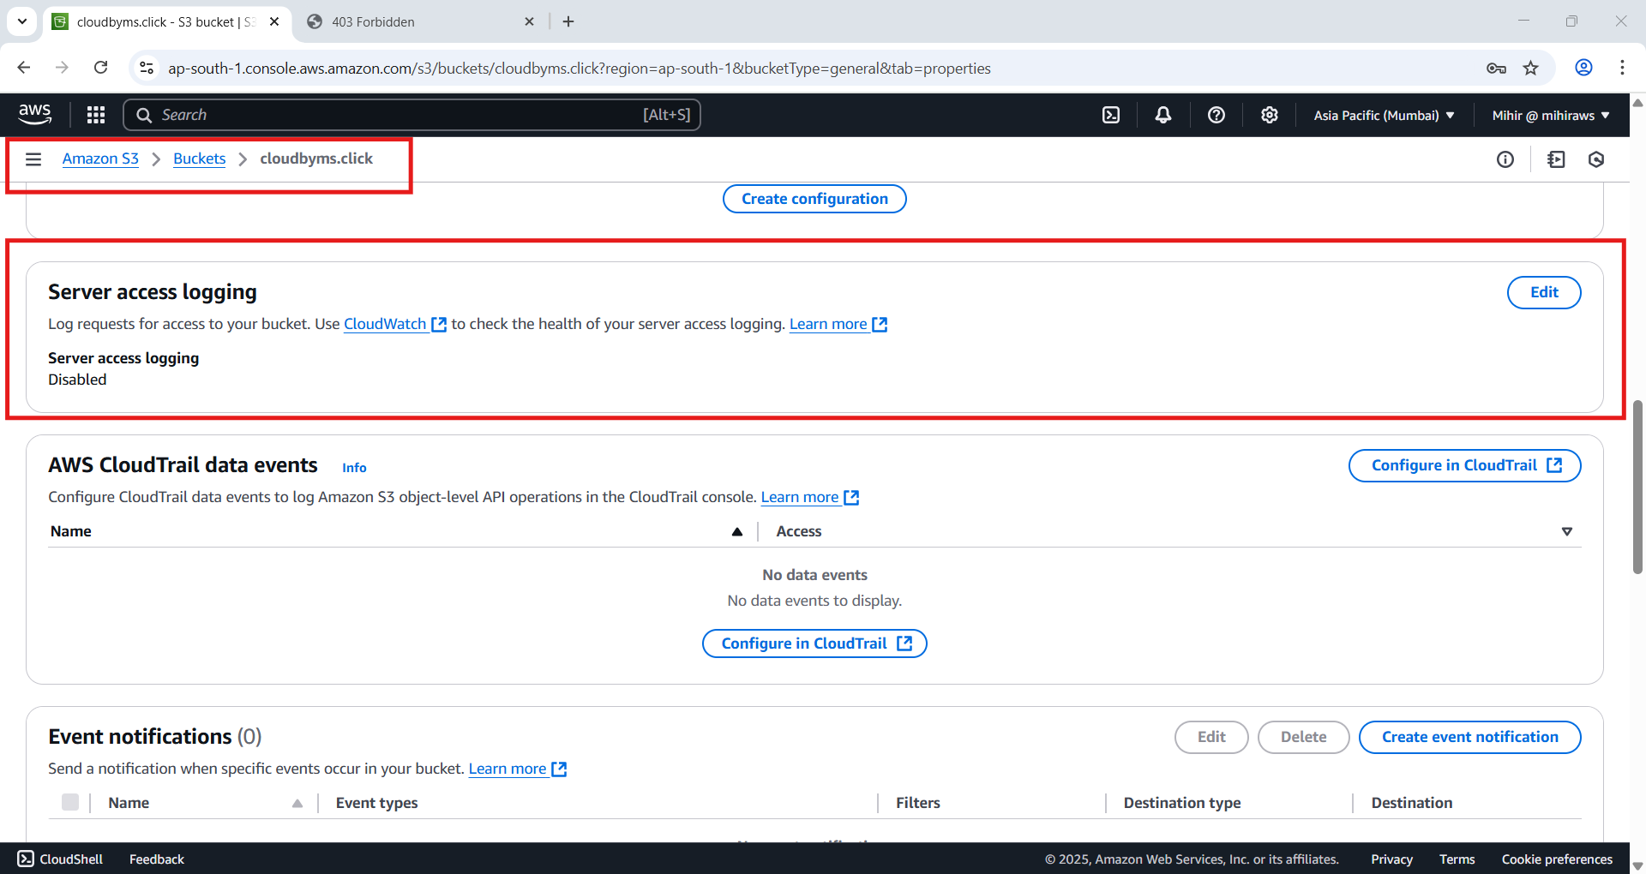

Figure 28 Select your root bucket and under 'Properties' tab go to 'Server Access Logging' and hit 'edit' button.

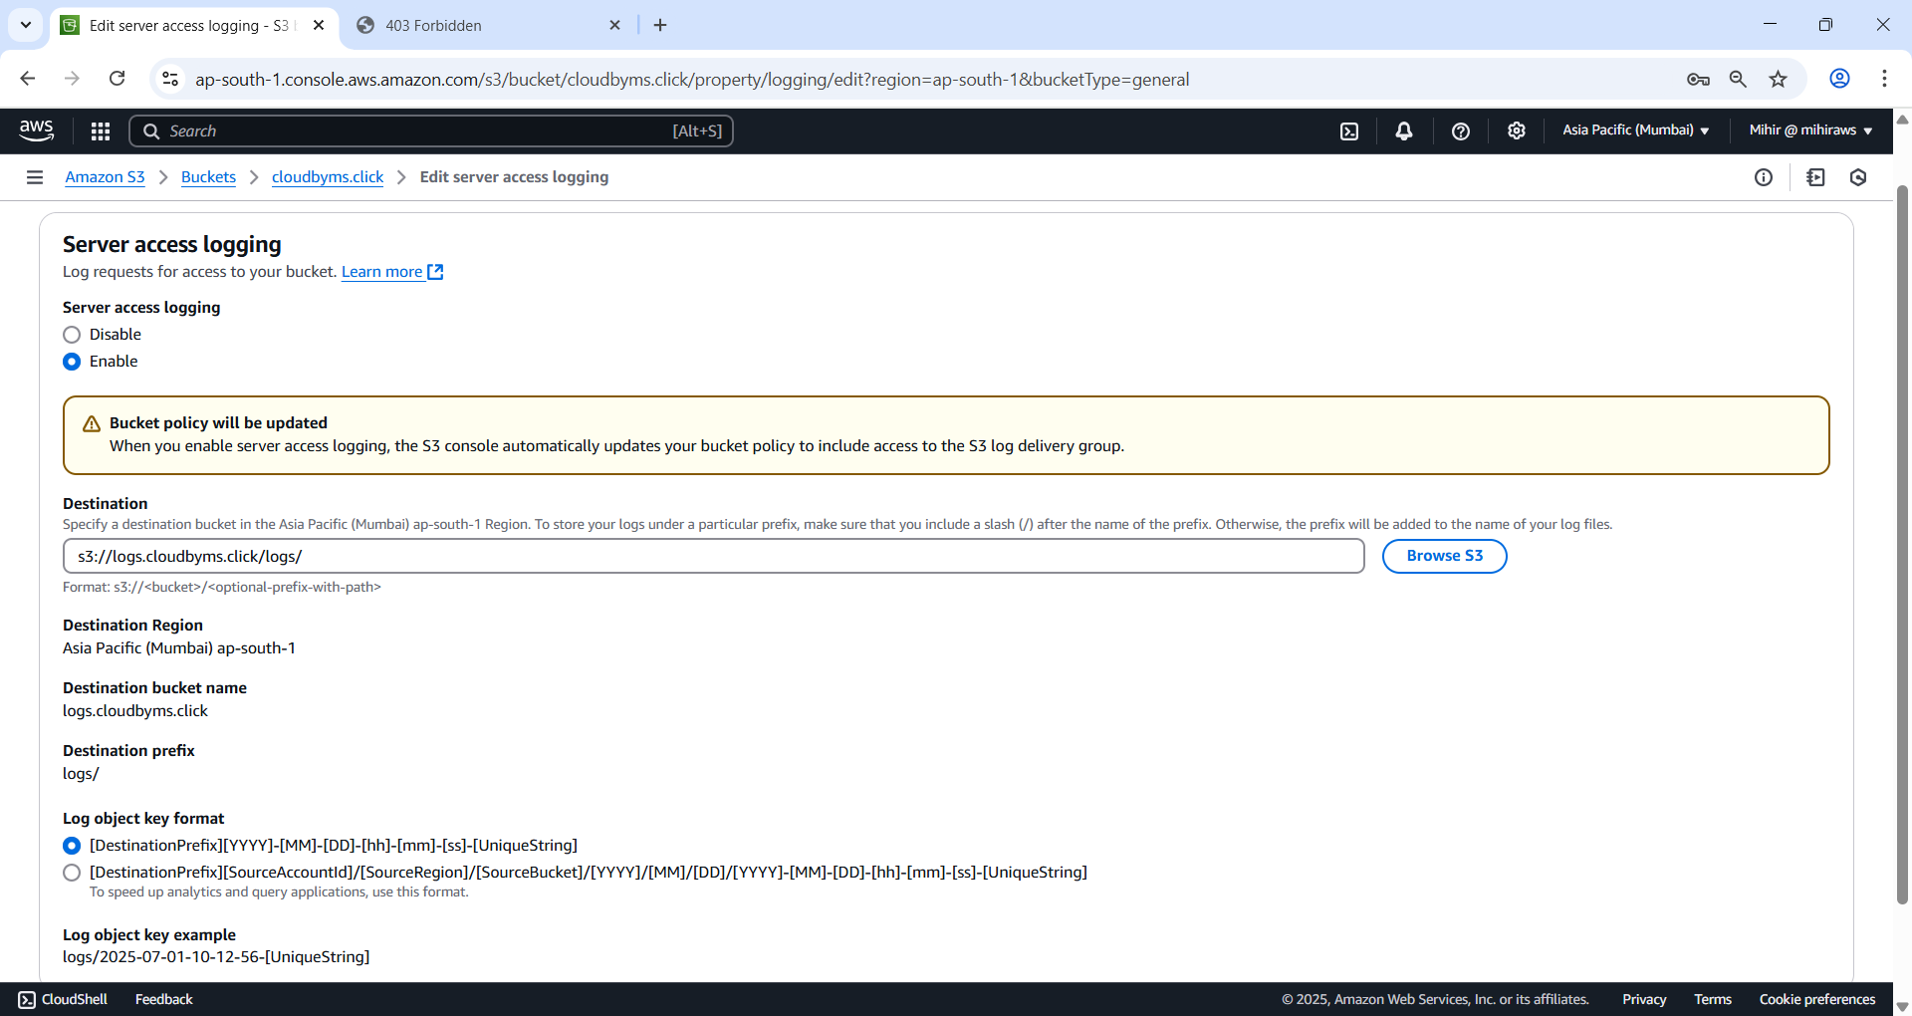

Figure 29 Enable Server Access Logging and under destination enter the path to the log folder under logs.cloudbyms.click by using 'Browse S3' button.

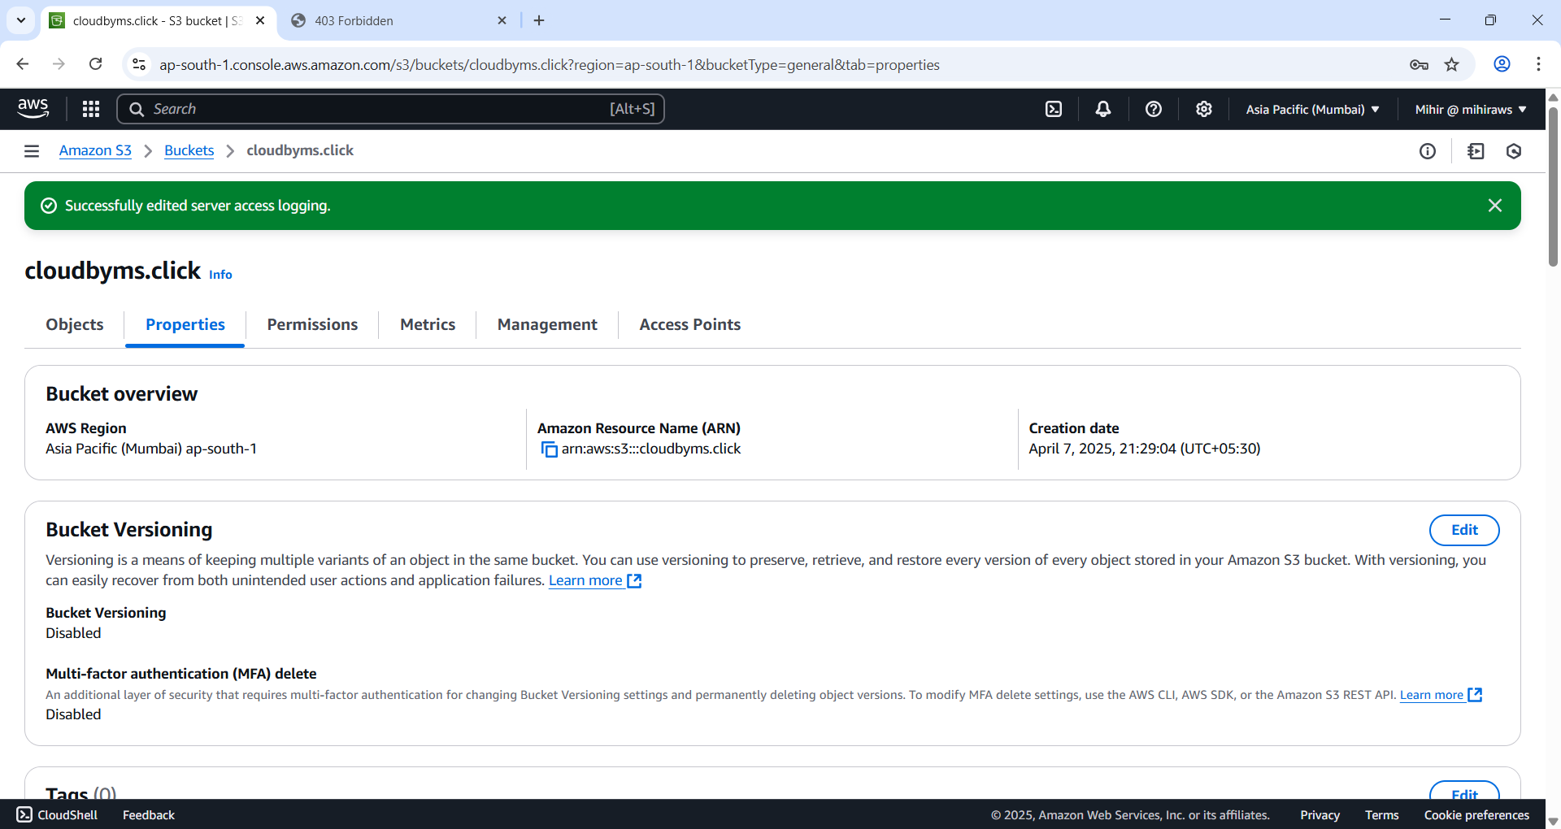

Figure 30 Successfully edited.

Amazon S3 writes website access logs to your log bucket every 2 hours.

### Upload files to the bucket

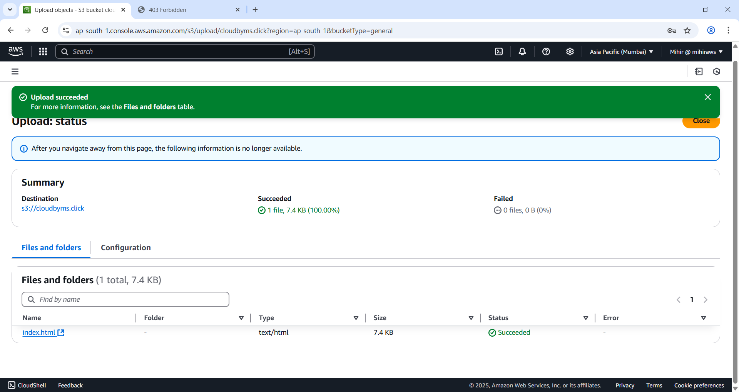

Figure 31 Uploaded index.html

Similarly upload error files to the bucket.

### Edit S3 Block Public Access settings

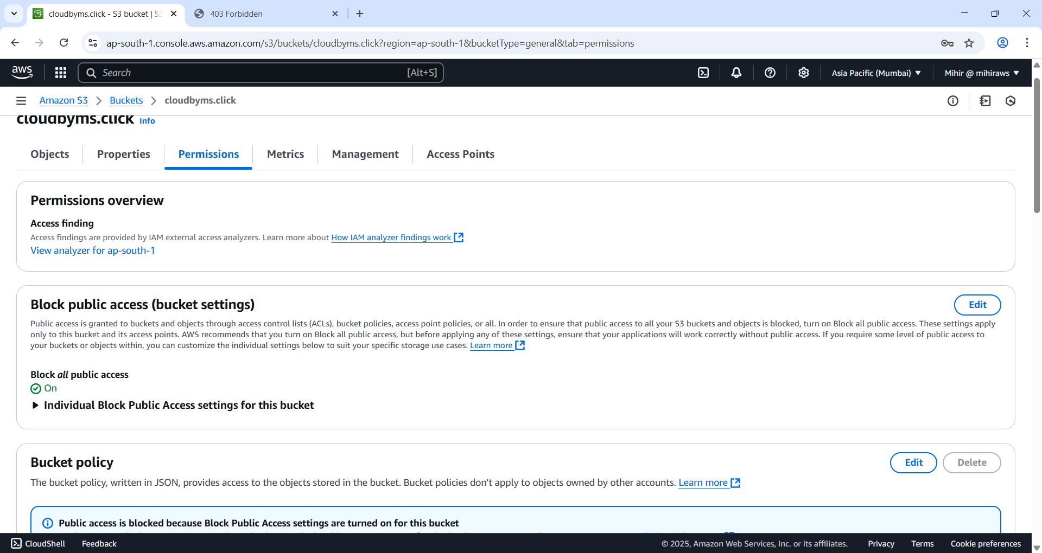

Figure 32 Select the root bucket and under 'Permissions' tab edit the 'Block public access (bucket settings)).

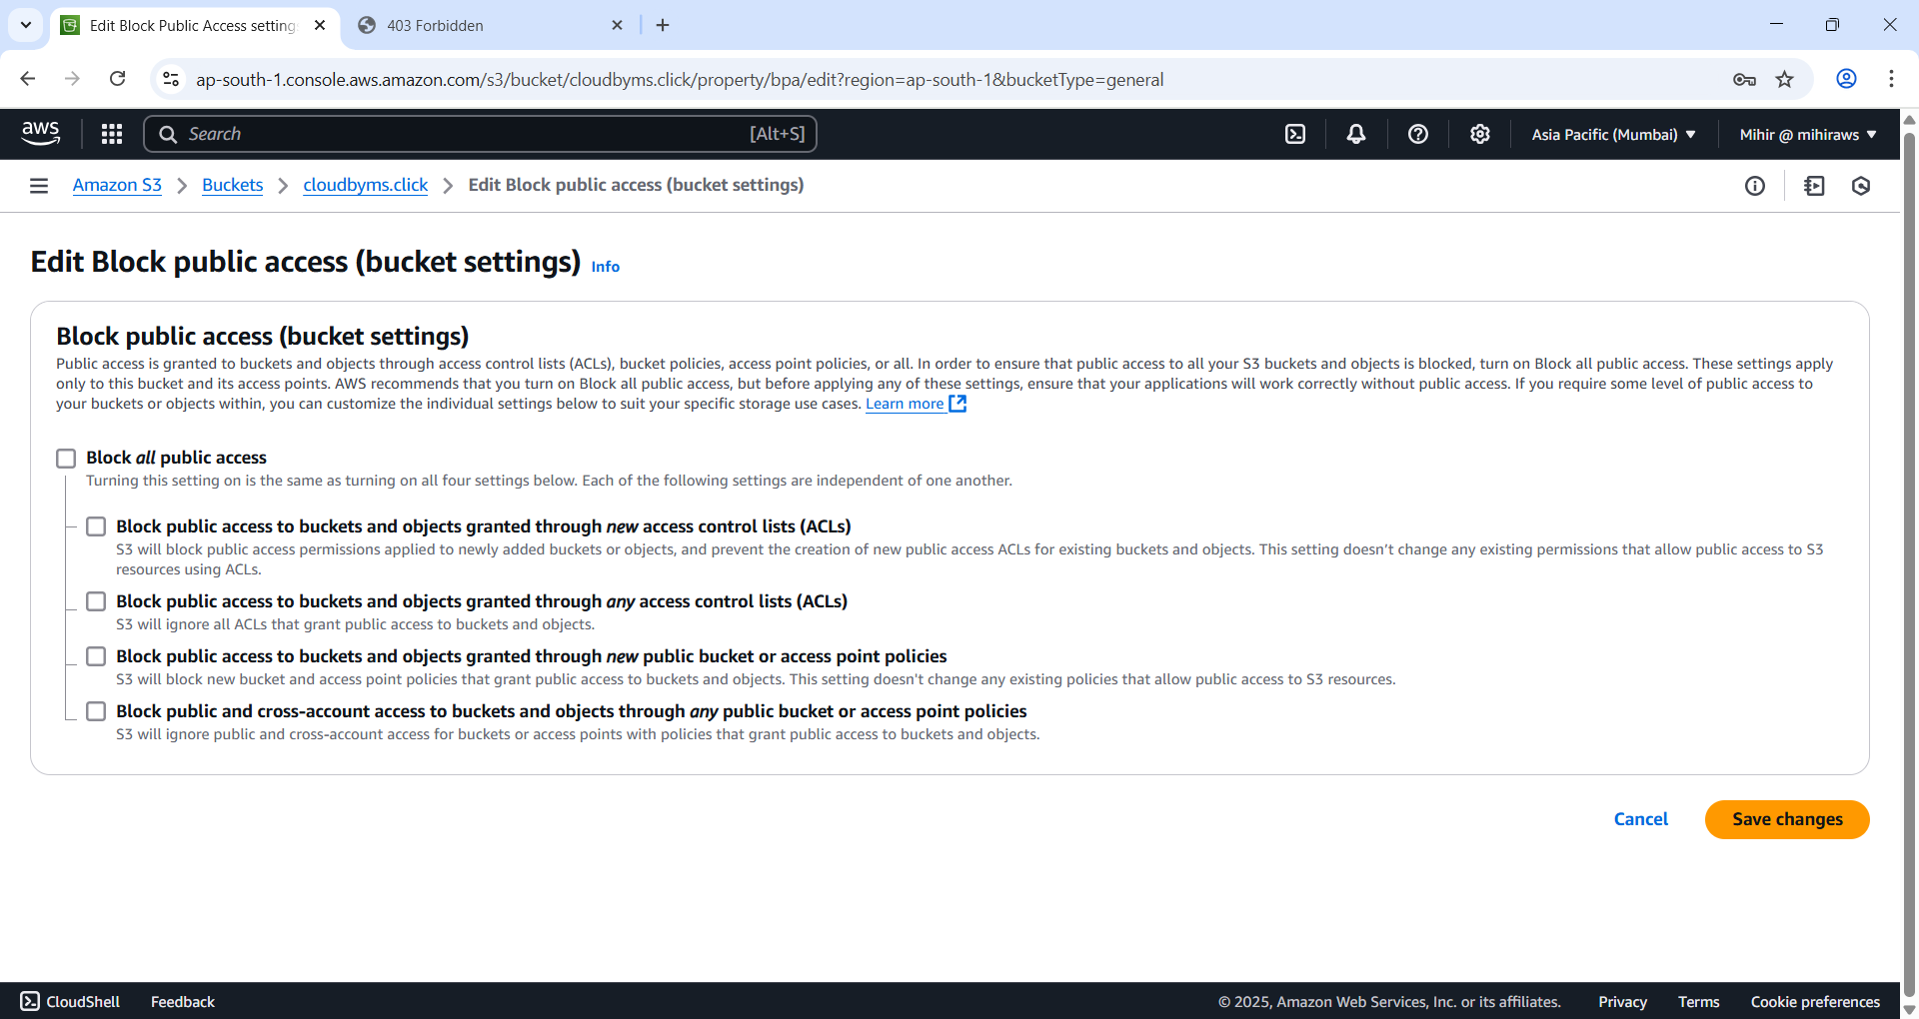

Figure 33 Uncheck Block all public access and save changes.

### Edit root domain bucket policy

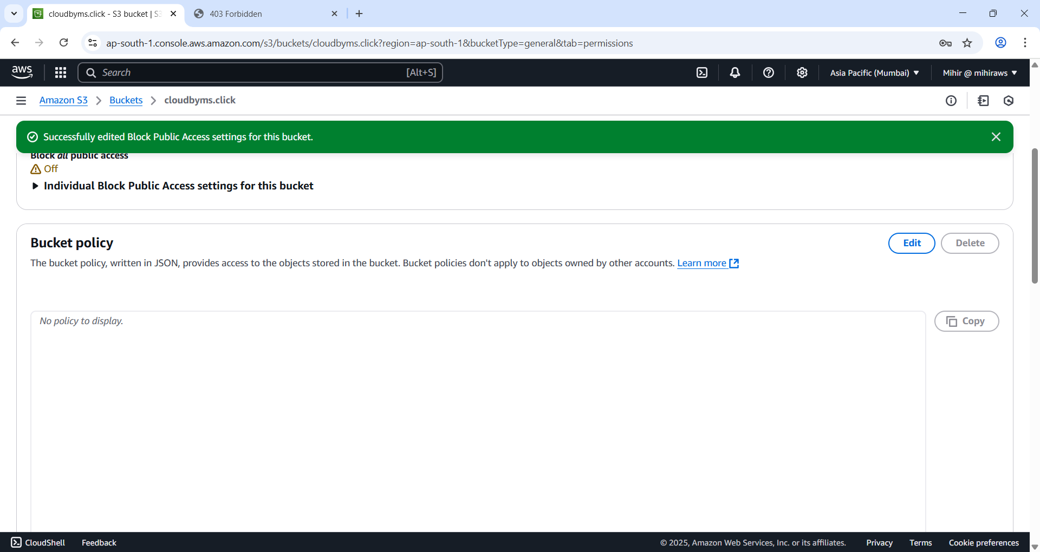

Figure 34 Scroll down and go to 'Bucket policy' and edit it.

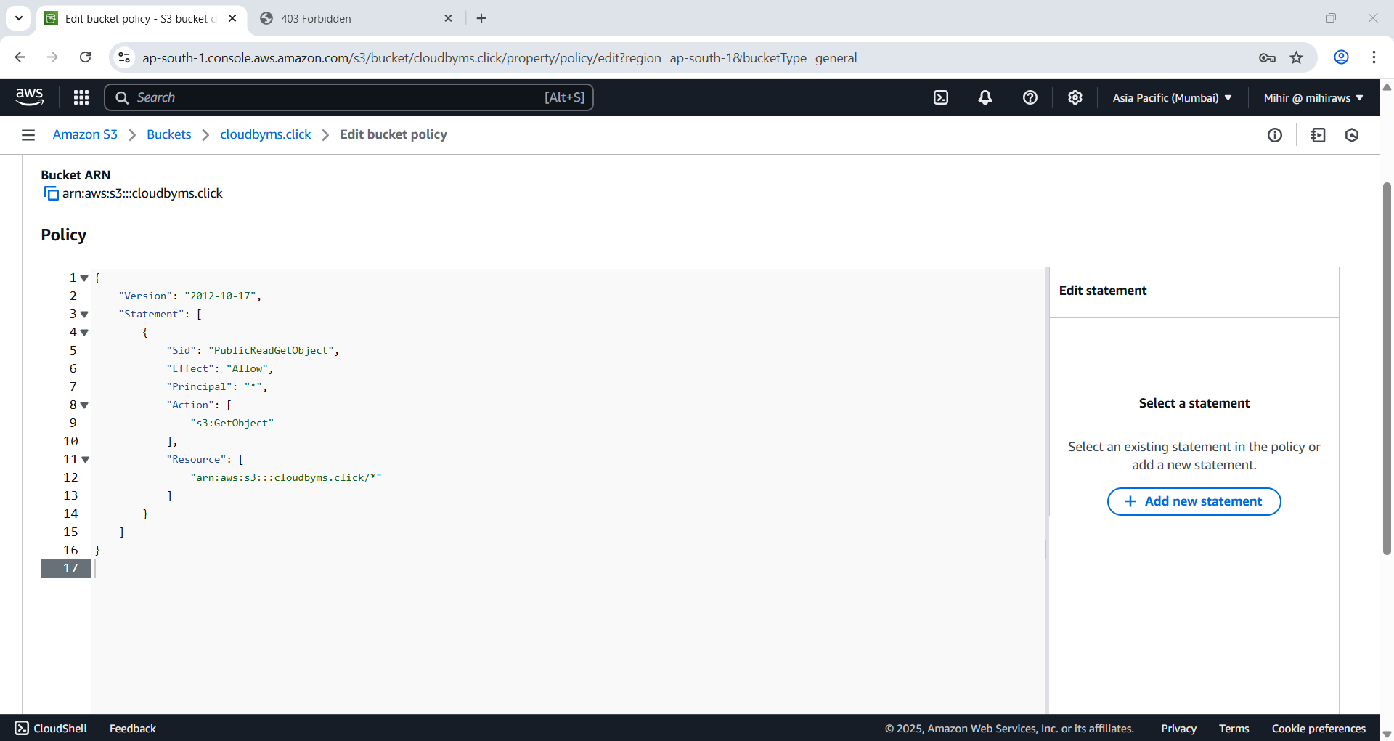

Figure 35 Edit the bucket policy to allow public access to the objects to all objects.

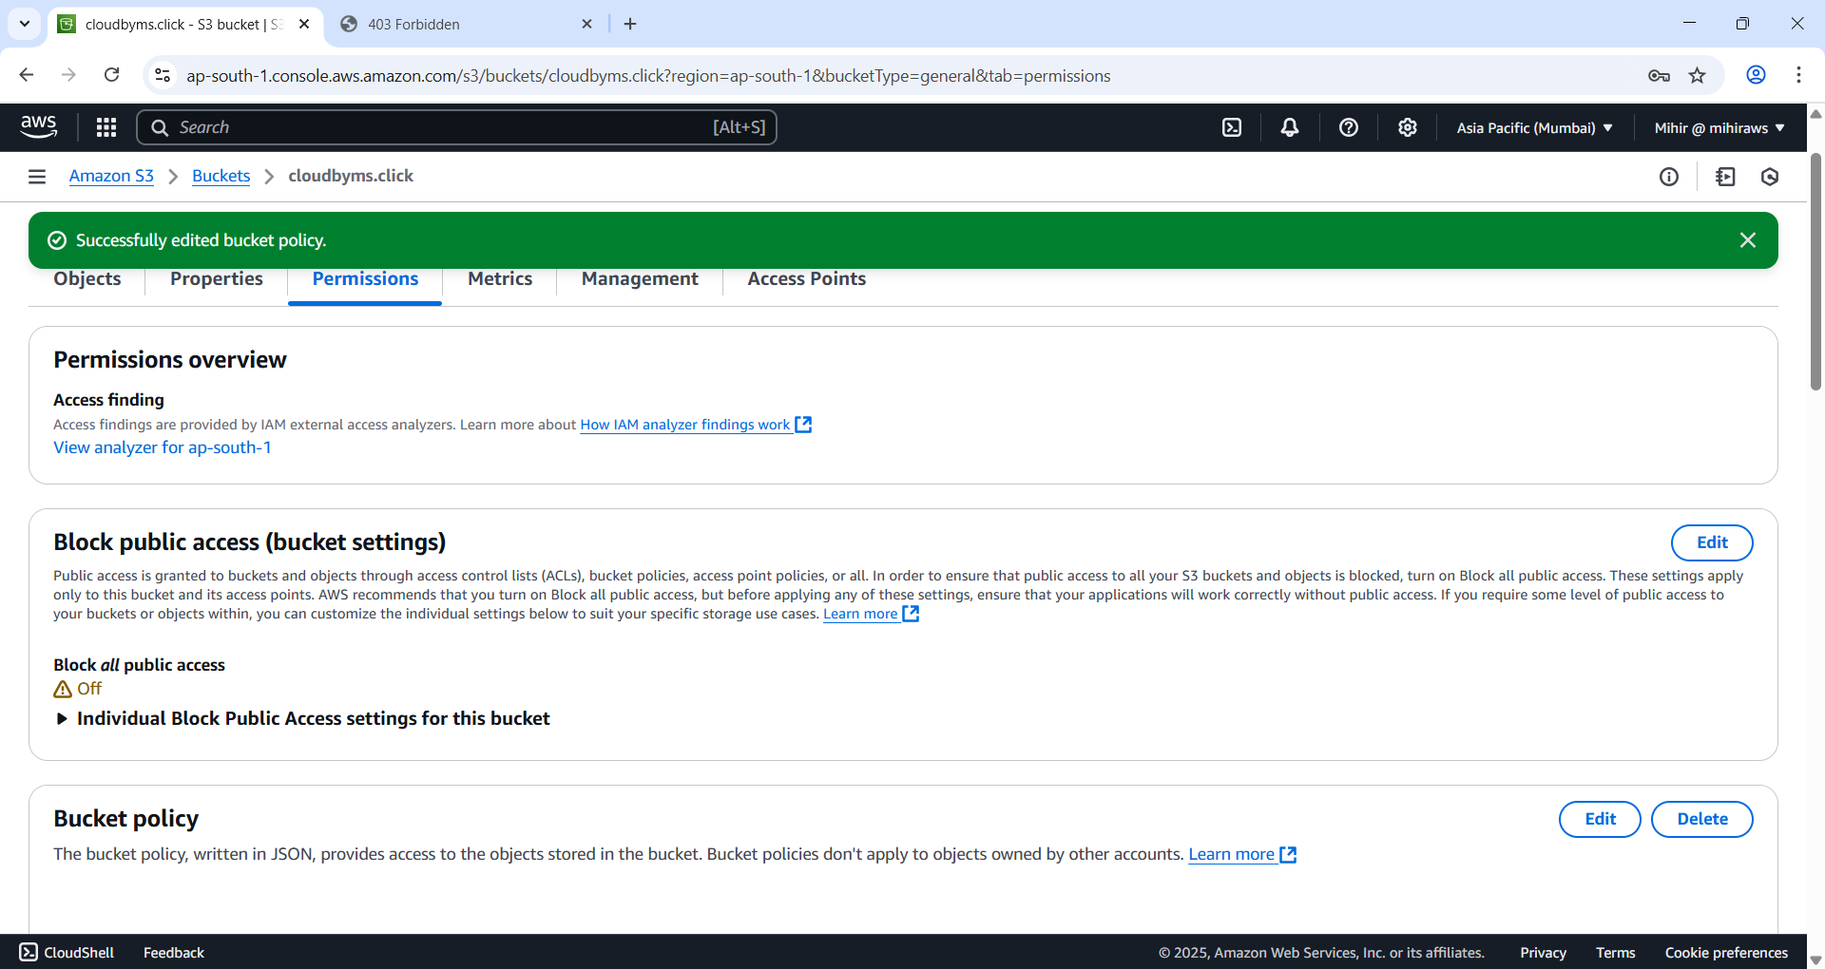

Figure 36 Successfully changed.

### Finally test if website is up

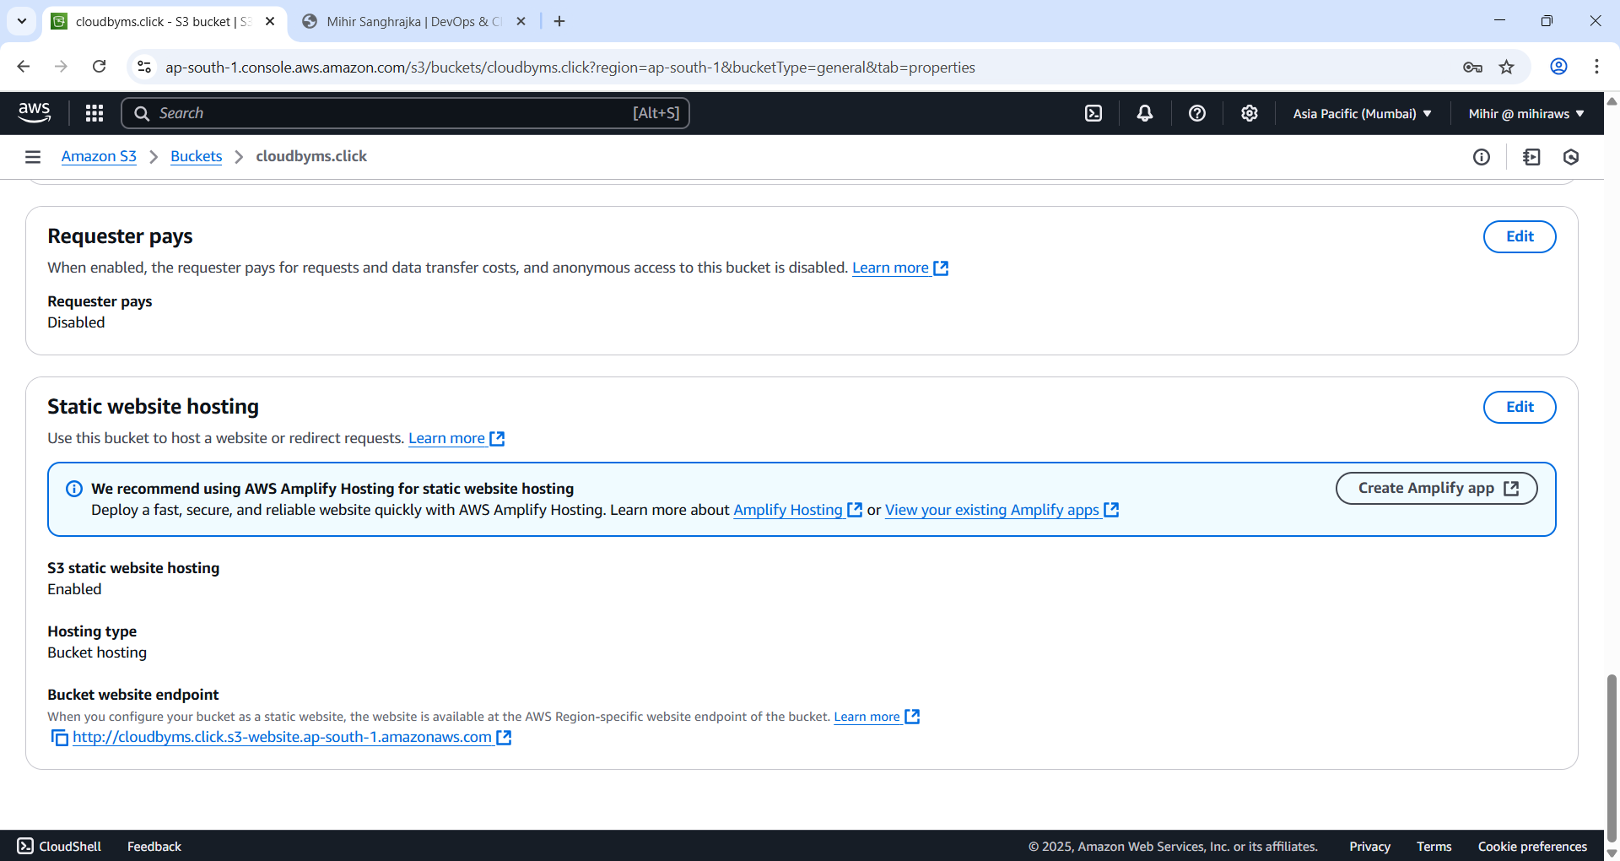

Figure 37 Go to root domain bucket and under Static website hosting copy and paste url into new tab.

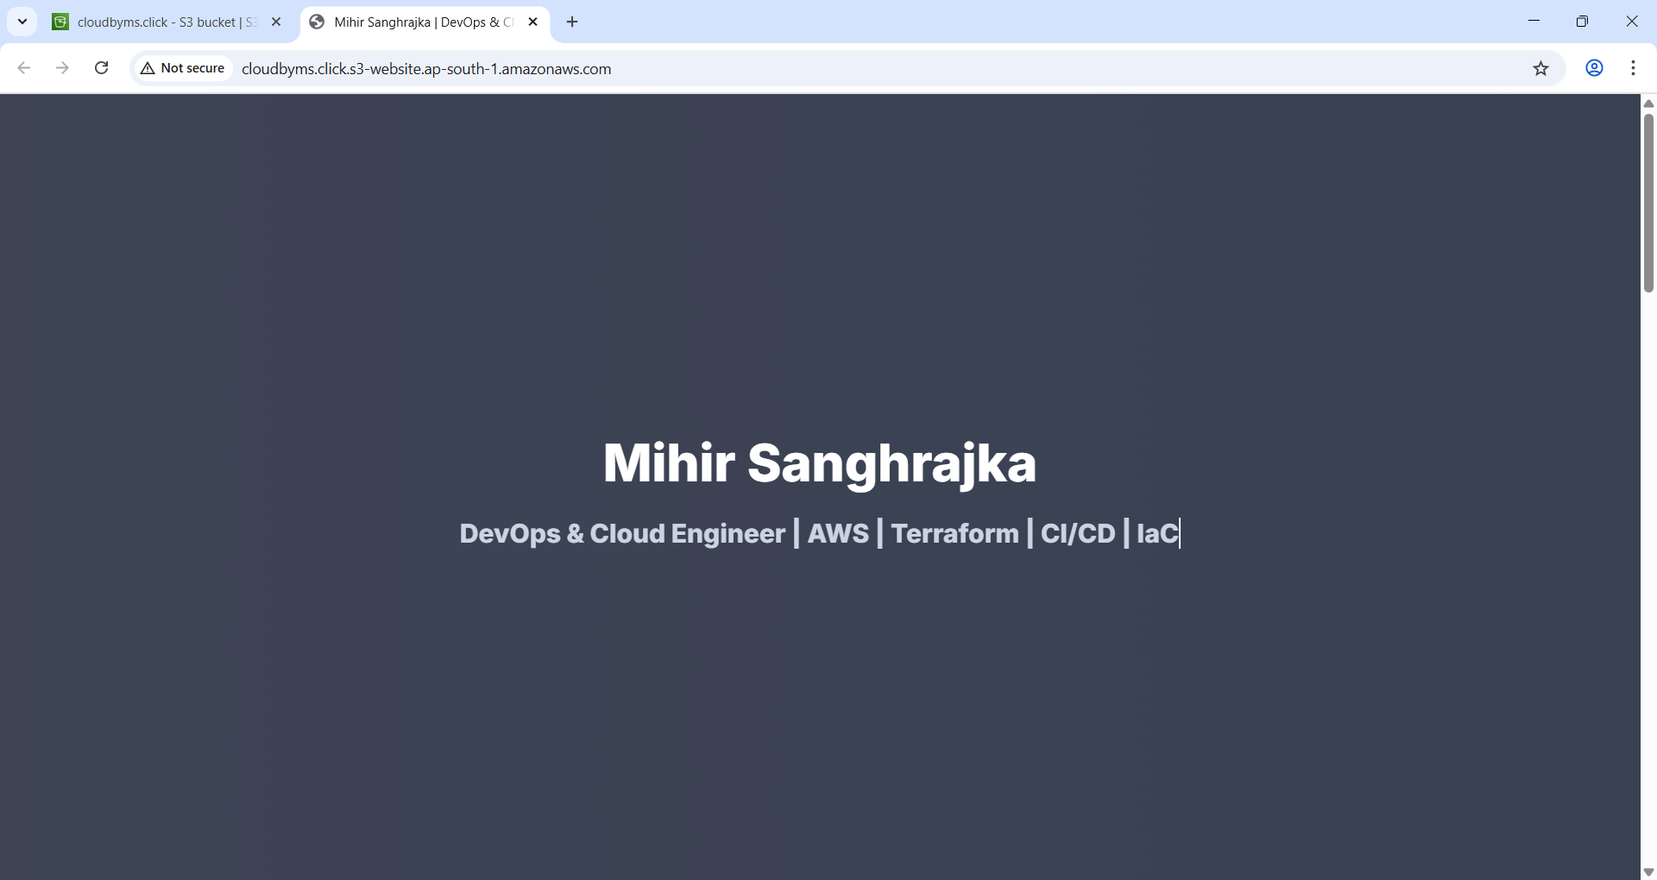

Figure 38 And my website is working.

### Add alias to domain and sub domain

Go to Route53 console page.

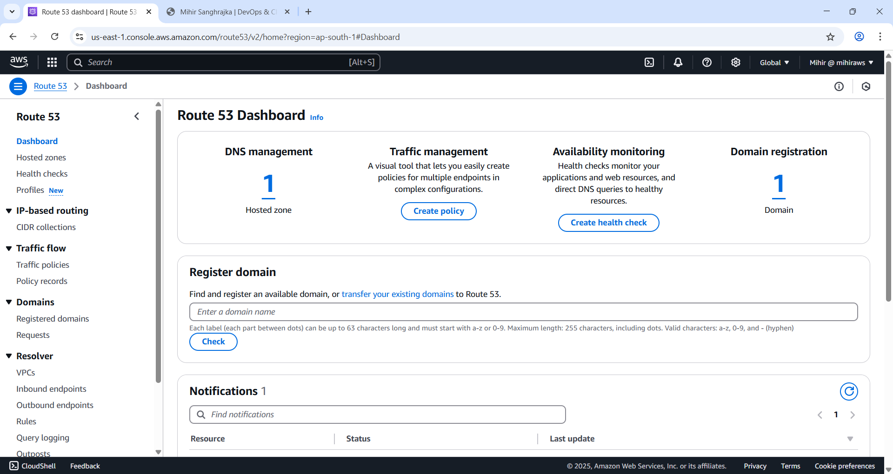

Figure 39 Route53 console page.

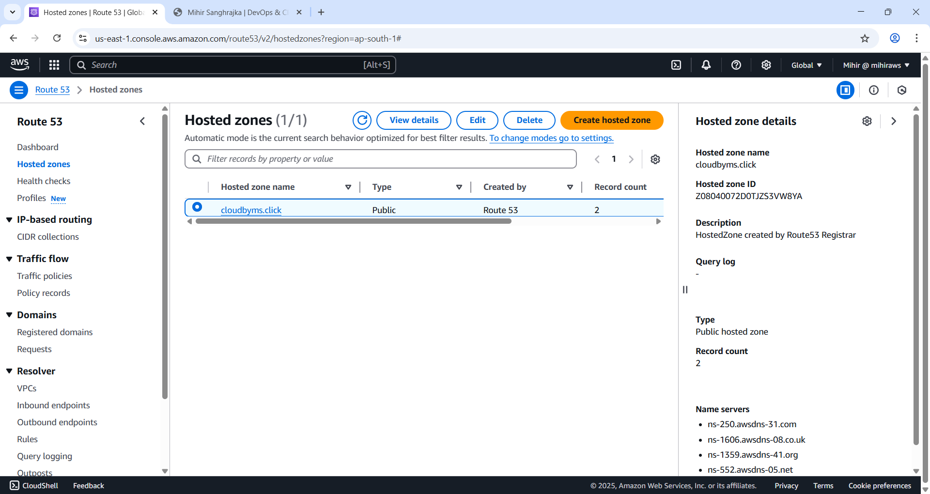

Figure 40 Go to hosted zone.

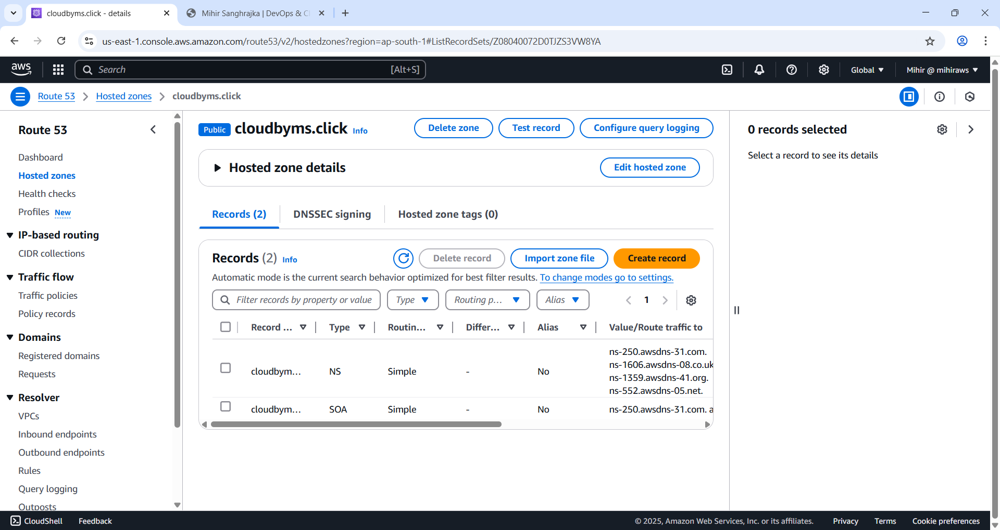

Figure 41 Select the hosted zone and hit 'Create record' button.

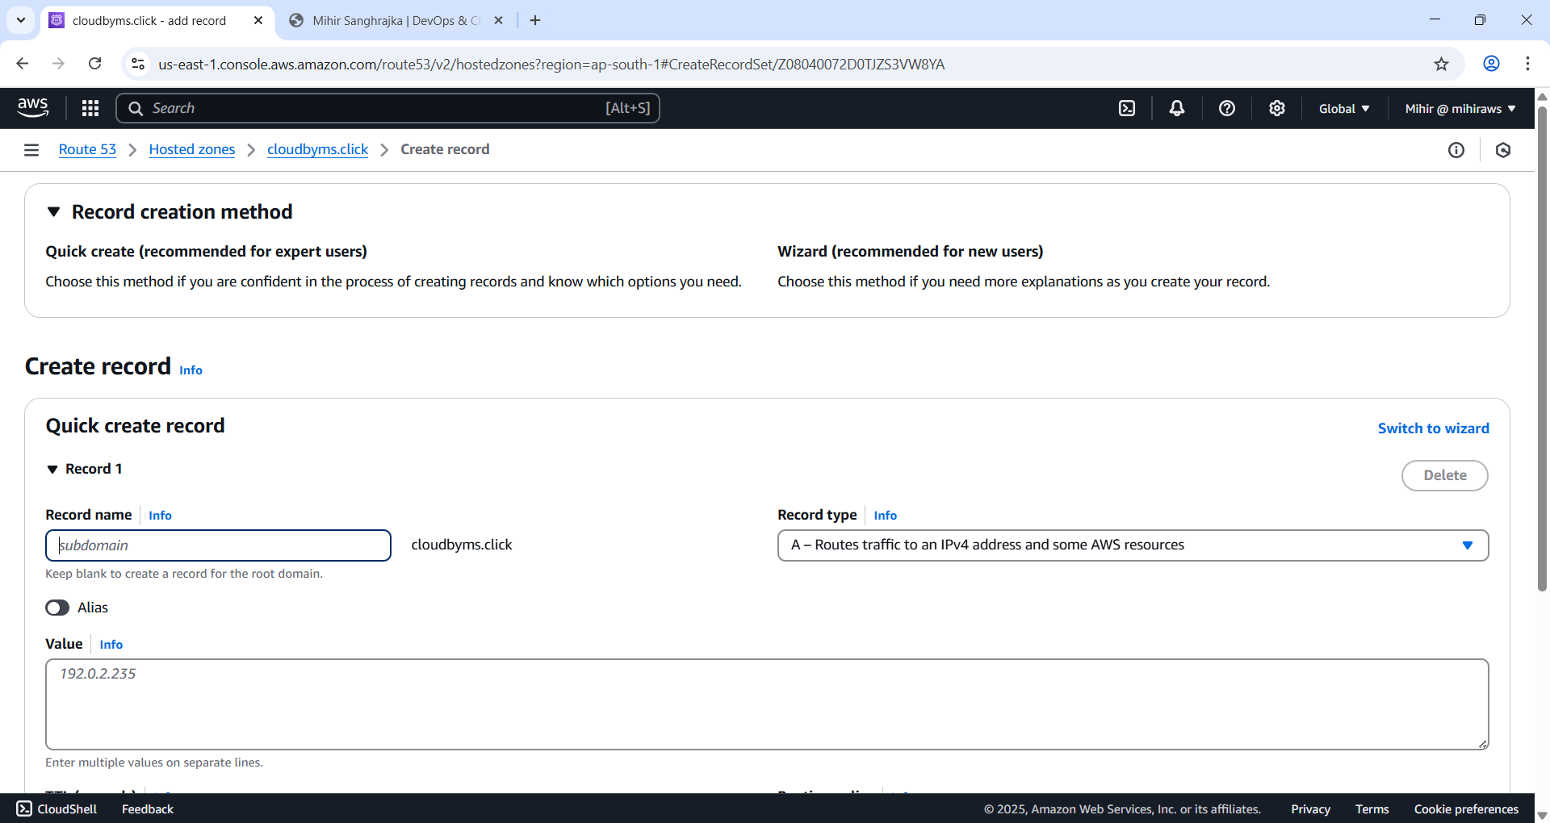

Figure 42 Choose 'Switch to wizard'.

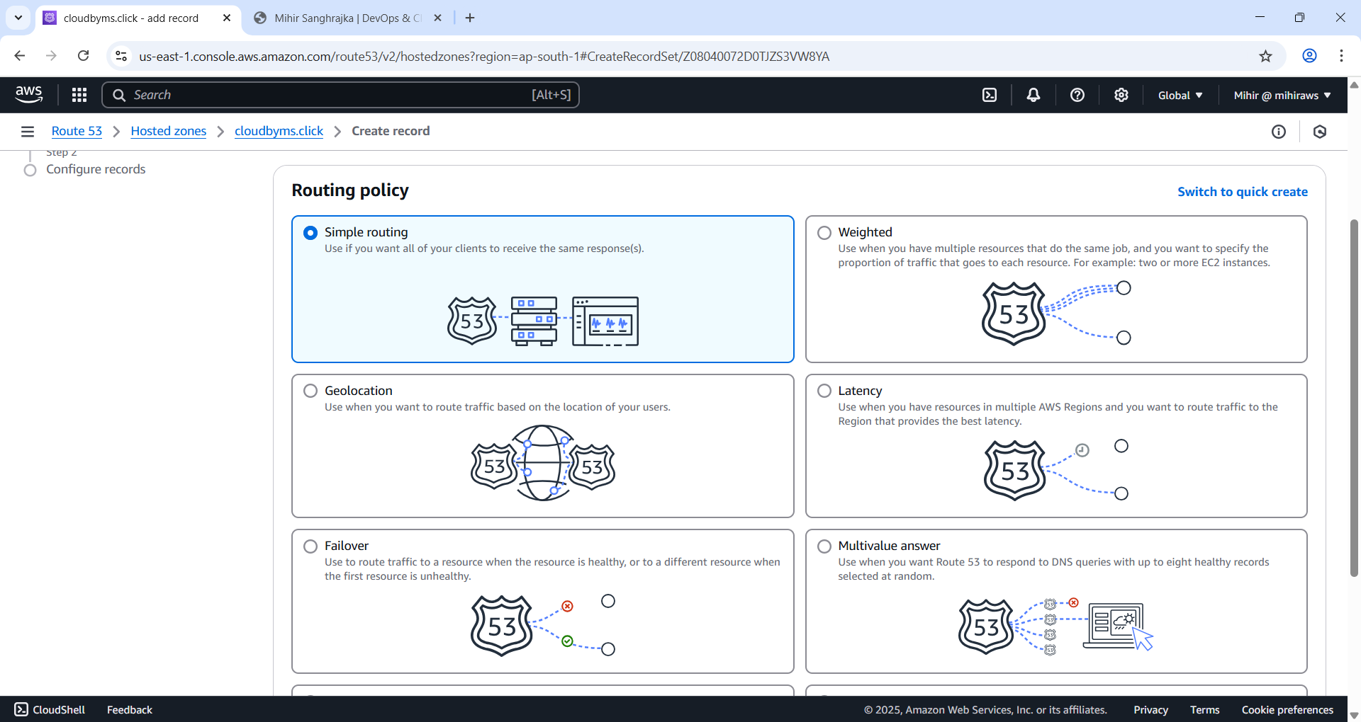

Figure 43 Choose 'Simple Routing' and hit 'next'.

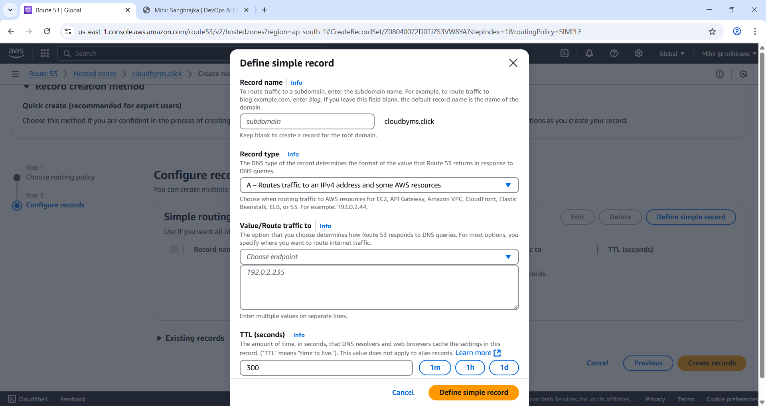

Figure 44 Choose 'Define Simple Record'.

Select Record Type as ‘A ‐ Routes traffic to an IPv4 address and some AWS resources’

Select Value/Route traffic to ‘Alias to S3 website endpoint’

Record name should be left blank

Choose S3 bucket select the bucket enter the Amazon S3 website endpoint for the Region where the bucket was created.

For Evaluate target health, choose No.

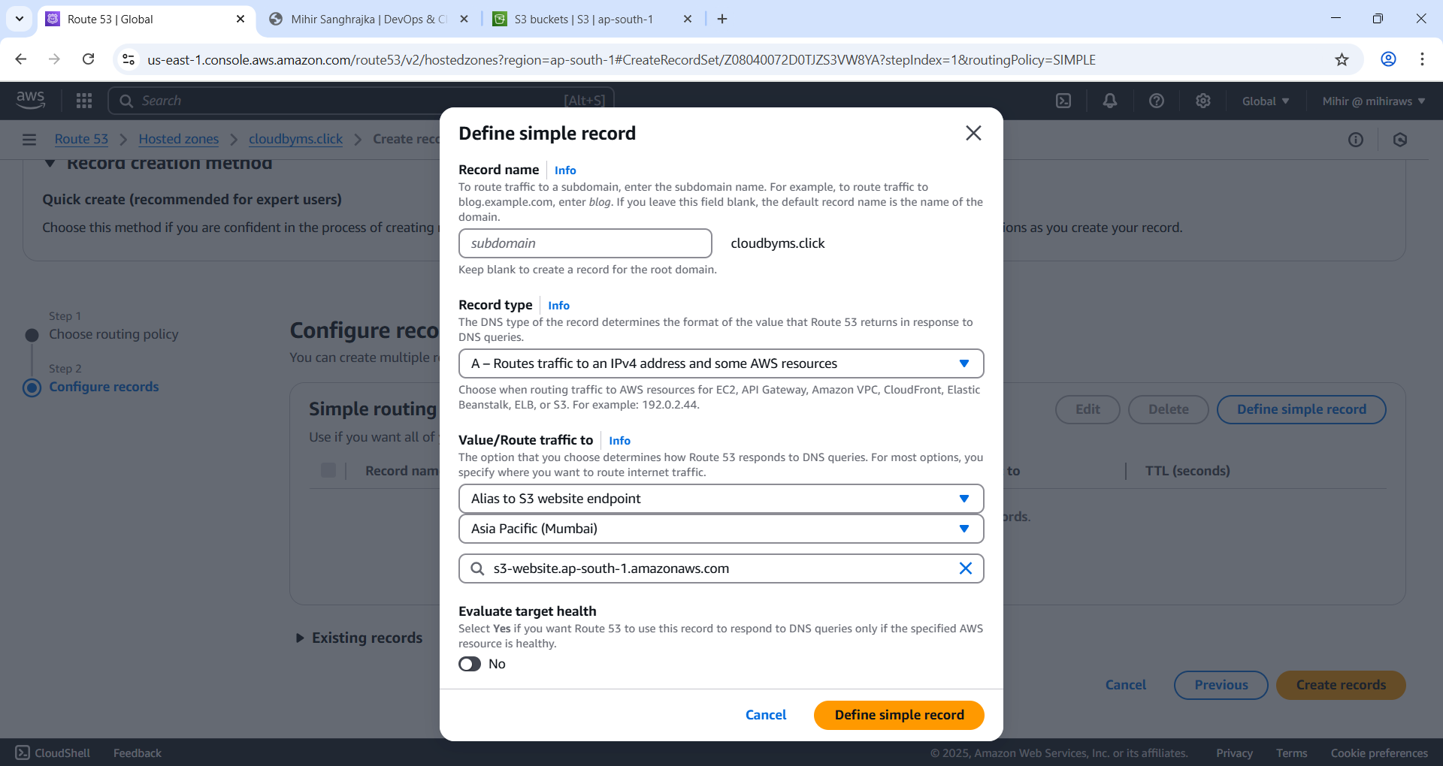

Figure 45 Choose defined simple record.

For sub domain

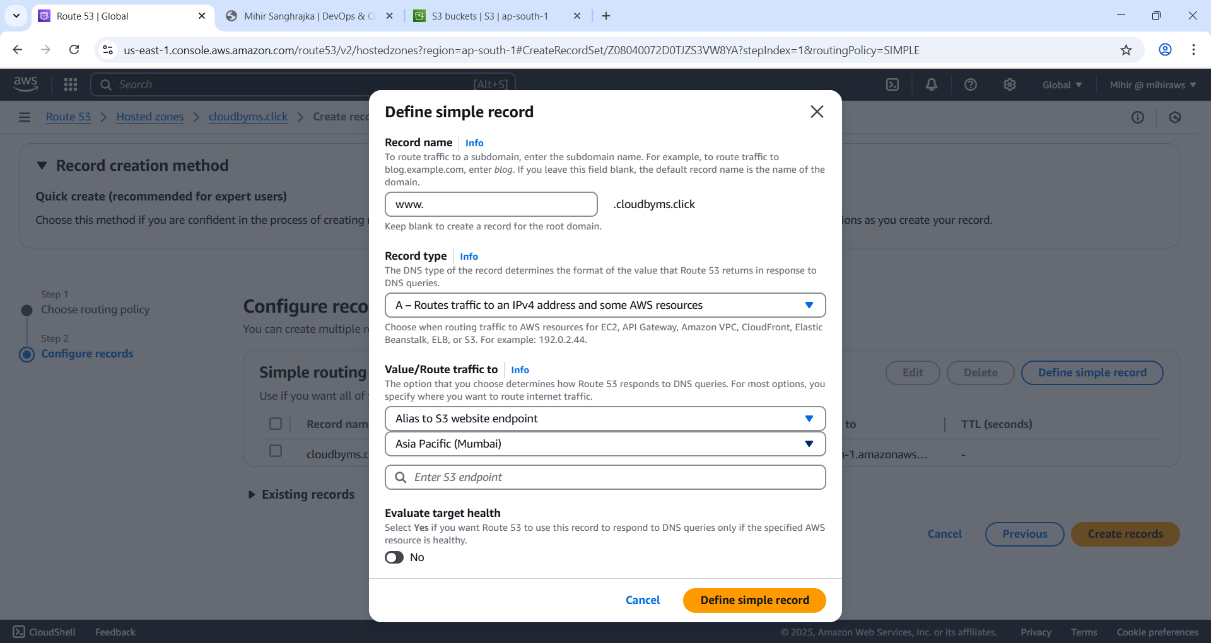

Figure 46 Repeat same steps only difference is Record Name with www. And hit create record.

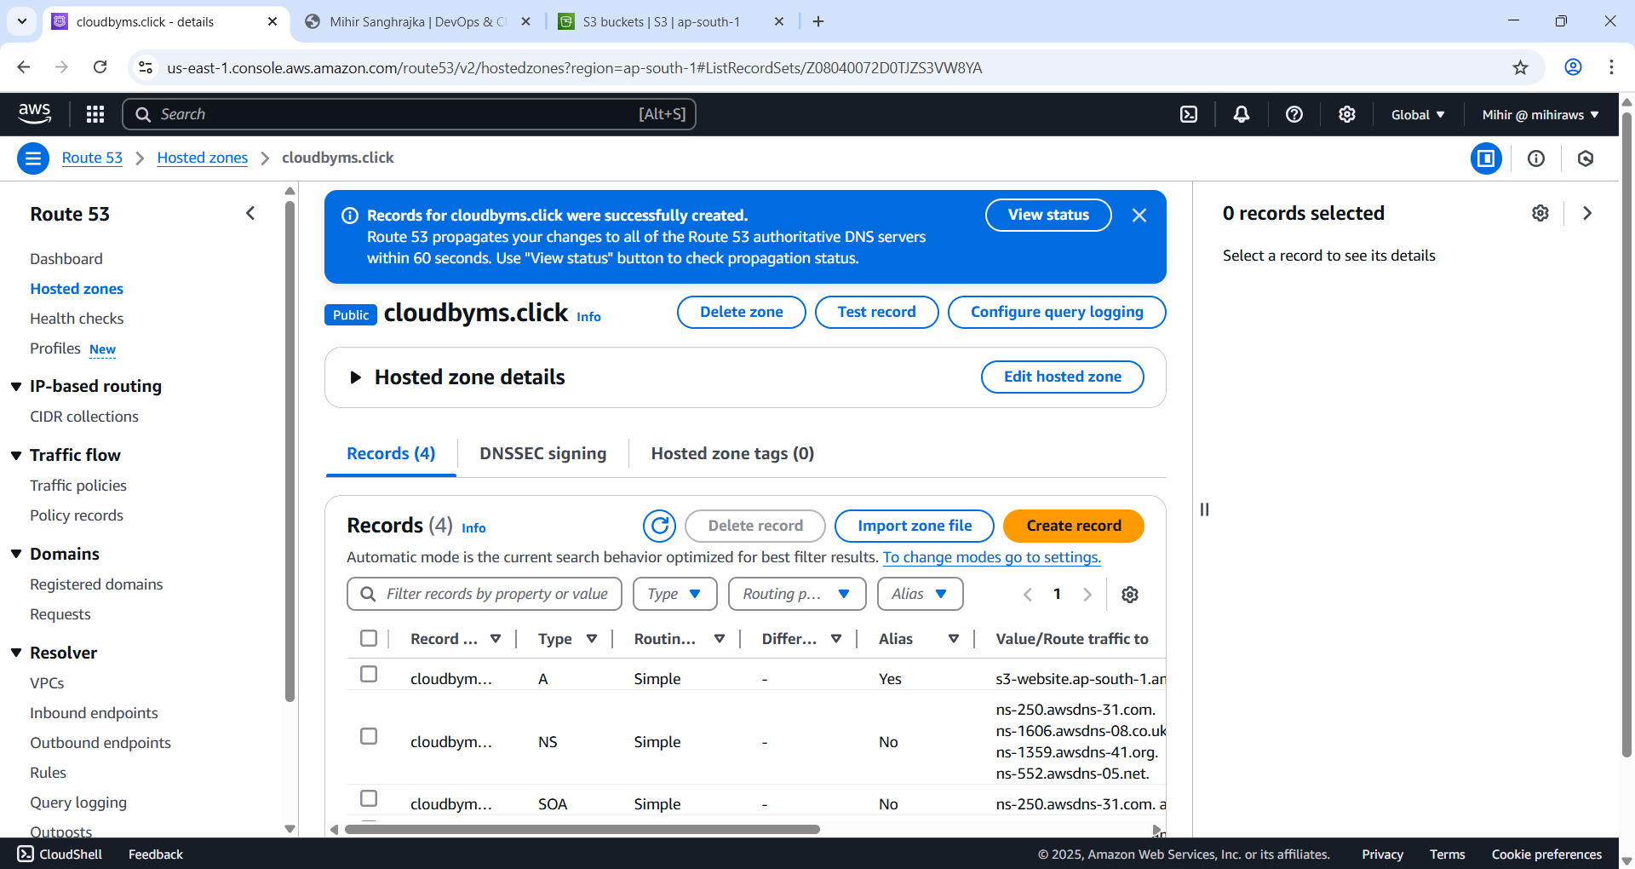

Figure 47Records created.

### Test the website

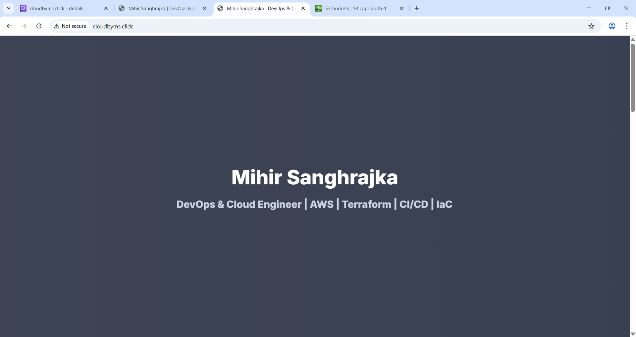

Figure 48 Successfully working.

If you type in cloudbyms.click it should be working. For you it must be <http://domainname.tld>.

### Learnings

Through this project, I gained hands-on experience with AWS Route 53 and Amazon S3 for hosting a static website. I learned how to register a custom domain name using Route 53, configure hosted zones, and set up DNS records for root and subdomains. I understood the importance of matching S3 bucket names with the domain name and configuring static website hosting, including index and error documents.

Additionally, I learned how to:

* Set up redirection from a subdomain (www) to the root domain.
* Enable and configure server access logging for monitoring purposes.
* Modify S3 Block Public Access settings to make content publicly accessible.
* Write and apply bucket policies to allow public read access.
* Create Route 53 alias records to route traffic to the S3 website endpoint.
* Use best practices in choosing regions and setting up cost-effective configurations.
* Understand the role of Route 53 in routing traffic both inside and outside the AWS ecosystem.

This project helped me understand the complete workflow of hosting a static website on AWS, from domain registration to final deployment and testing.

A kind thank you to the AWS team to making such tutorials.  
Reference: <https://aws.amazon.com/tutorials/>